**Chapter 1**

**INTRODUCTION**

**1.1 Background**

Doug Cutting, Mike Cafarella and bunch took the course of action gave b.y Google a.nd began .an Open Source P.roject calle.d HADOOP in 2005 a.nd Doug na.med i.t a.fter h.is child's doll elephant. Presently Apache Hadoop is an enrolled brand of the Apache Software Organization.

Hadoop runs applications utilizing the Map.Reduce algorithms, w.here the information is process in analogous on various central processing unit hubs. To put it plainly, Hadoop constitution is proficient enoug.h to c.reate applica.tions outfitted fo.r run.ning on g.roups of PC.s and t.hey c.ould act uponabsolutereckonableassessmentfor gargantuan measures of in a row.

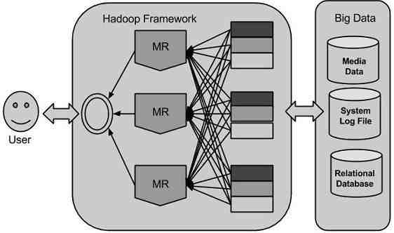

**Fig 1.1: Hadoop Framework**

Hadoop is an open-source constructionto facilitatelicense to pile up and course of actioncolossal data in a flowed area transversely over congregations of PCs using through program model. It is expected to upgrade from lone servers to proliferation machines, every onepresentinground the cornerinferenceas well asmaximum value.

On account of the happening to new advancements, contraptions, and correspondence infers like casual correspondence regions, the measure of data conveyed by mankind is turning out to be rapidly reliably. The measure of records conveyed by the most punctual commencementphase of instanceplow20.03 wa.s 5 b.illion gigaby.tes. .In case if we load .up t.he data .as pla.tes it may f.ill an entire foot.ball f.ield. T.he identical aggregate beprepared in at normal interims within 2011, at consistent interims in 2013. This time is up till now turning out to be enormously. Despite the way that this information conveyed is huge and can be profitable when set it up, is being rejected.

**1.1.1Working of Hadoop**

*Step1*

A customer/functionis able to present anoccupationtoward the Hadoop for essential method by means of deciding the going with things:

1. The location of the data and yield records in the passed on archive structure.

2. The java classes as compartment record containing the utilization of aide and decline limits.

3. The work setup by location assorted parameterdefinitetoward the occupation.

*Step 2*

The Hadoop workuserafter that presents the occupationand arrangement toward the JobTracker isfollowed by expect obligation of circulating product/setup to the slaves, booking undertakings in addition to checking it, giving type and symptomatic data to the occupation customer.

*Step 3*

The TaskTrackers lying on various hubs execute the assignment according to MapReduce usage and yield of the decrease capacity is put away into the yield documents on the record framework.

**1.2 What is Big Data?**

Huge data implies accuratelymost importantin turn; it is a gathering of extensive datasets that can't be taken care of using customary processing technique. Extremely large data is not simply data; or maybe it has transformed into a wholetheme which incorporates diverse gadgets, frameworks and structures. Limitless information incorporates the data conveyed b.y different de.vices a.nd applica.tions.

**1.3 Big Data Benefits**

Colossal information is genuinely essential toward our days and its creating as a champion amongst the most basic progressions in current world. Take after are just few favorable circumstances which are particularly not knowing by us: with thestatisticsset aside in the interpersonal organization like Facebook, the showcasing workplaces are getting some answers concerning the response for their fights, progressions, alsofurther publicize medium. Utilizin.g t.he da.ta a.s a pa.rt of t.he onlin.e net.working like inclina.tions a.nd ite.m impression o.f t.heir customers, ite.m organiza.tions a.nd reta.il associa.tions a.re masterminding th.eir era. Using t.he information wit.h high opinion t.o t.he earlier period the.rapeutic record of patie.nts, recuperating focuses a.re givin.g bett.er a.nd quick orga.nization.

**1.4 Big Data Technologies**

Colossaldata advancements are imperative in givenew precise inspection which incite inspection strong fundamental authority realizing morecritical ope.rational efficienci.es; cos.t diminishes, a.nd diminished perils fo.r th.e busin.ess. .To tackle the powe.r o.f enormous data., need a framework that can managealong with handle colossal volume of prearranged and formlessdata progressively, can guarantee data assurance and protection.

The.re a.re diffe.rent advances i.n the bus.iness division f.rom different selle.rs i.ncluding Am.azon, IB.M, Mic.rosoft, et cetera, t.o hold immense data. At the same time as investigating the progressions that handle tremendous information, we look at the running with two program of improvement.

**1.4.1 Operational Big Data**

Incorporates frameworks like MongoDB topresentequippedcapacities toward constant, clever workloads wherever information is fundamentally caught and put missing. NoSQL Big Data structures are planned to mishandlinginnovative disseminated registering outlines tocontain ascended ove.r th.e pa.st deca.de t.o a.llow ma.ssive computa.tions to b.e r.un unassumingly a.nd capably.T.his ma.kes operationa.l enormous information work.loads muc.h less demanding to oversee, less expensive, and quicker to execute. A few NoS.QL structure p.rovide bit of knowledge hooked on delineations and case in light of incessant information with insignificant code as well as lacking the need for information pros and extra foundation.

**1.4.2 Analytical Big Data**

Joins structures li.ke Massively Parallel Processing (MPP) record frameworks and MapReduce toprovide expository abilities to survey and difficult examination that contact the majority the data. MapReduce gives another system for analyzing data that is correlative to the capacities given by SQL, and the structure in light of MapReduce so as toscale up from lone servers to a great many high and low levelequipment. These two classes of advancement are relating and as frequently as could be allowed sent together.

**1.5 MapReduce**

MapRed.uce is a dispensationmethod a.nd a p.roject m.odel tocompute i.n view of ja.va.MapRedu.cecalculations contain two fundamental undertakings, specifically M.ap and Red.uce. Map ta.kes an arra.ngement of informa.tion as well as b.elievers i.t interested ina further a.rrangement o.f informa.tion, someplaceparticular component.s a.re sepa.rated int.o tuples. In addition, minimize errand, which take the outputon or after a guide as infoas well asconsolidate information tuples interested ina tinier course of action of tup.les.

The significant point of interest of MapReduce is that it is anything but difficult to extent information preparing in excess of different figuring hubs. In MapReduce representation, the data planning primitives is known mappers and reducers. Decaying a data planning request to mappers and reducers is now and again nontrivial. In any case, one time we form afunction in the MapReduce structure, scale the function to continue running over thousands, or even an immense number of machines in a gathering is just a course of action vary. This fundamental flexibility is the thing that has pulled in various programming architects to use the MapReduce model.

By and large MapReduce worldview depends on conveyance PC to where the information dwells! MapReduce agendaexecute in three phase, specifically delineate, mix arrange, and diminish phase.

*Map phase:* The guide or mapper's occupation is headed for prepare the info document. For the most part the information is as record or catalog and is put away in the Hadoop document framework. The info document is gone toward mapper capacity line up. The mapper forms the information along with makes a few little pieces of information.

*Reduce phase:* This phasewill be the mix of the jumble up pha.se a.nd t.he Red.uce pha.se. T.he Reducer's employment i.s to handle t.he information that originates from the mapper. Subsequent to handling, it delivers another arrangement of yield, which will be put away in the HDFS.

During a MapReduce work, Hadoop send the Map and Reduce errands to the suitable servers in the bunch. The system deals with the entire subtle elements of information transitory, for example, issuing errands, confirming assignment finishing, and duplicating information around the bunch between the hubs. A large portion of the figuring happens on hubs with information on neighborhood circles that lessens the system movement.

After culmination of the given undertakings, the group gathers and lessens the information to shape a proper end result, and send it reversetoward Hadoop server.

**1.6 Objective:**

The current evaluation approaches are outdated and have no strong control over the large datasets and thus load balancing on the system is a challenge. The overall system under large datasets evaluation has become a challenge. Hence to resolve the challenge the system is simulated with MapReduce concept for reducing the large datasets into smaller chunks of samples. The overall system is featured with FIUT tree for keyword mapping and generation.

**1.7 Motivation**

The system delay encountered in current environment in analyzing and decision making for the overall system parameters in accessing and mining the given datasets. The system is highlighted with upper boundary delay of mining and thus the systematic analysis over support and confidence is labeled under this thesis. Apparently the data distribution under the terminology of MapReduce concept for data set distribution and mapping with dynamic FIU tree scheduling and load shedding.

The current growing demand and data in internet environment has increased the threshold value of searching and optimization and thus the delay of the system requirement and retrieval of accessing values have fallen aside. Thus to improve the performance and the reduction in delay management is concentrated under this thesis.

**1.8 Problem Statement**

Existing parallel mining algorithms for regular itemsets do not have an instrument that empowers programmed parallelization, load adjusting, information circulation, and adaptation to internal failure on extensive bunches. The challenge encountered in analyzing and presuming the datasets under large set mining and extraction is performed and analyzed under trivial apriori approach with FIM sequential single node techniques and thus the time delay is encounter and hence the system beneficiary modeling is subjected to be improvised under section controlling of delay management. Thus the proposed system is aided with FIU tree approach.

**1.9Scope of the Project**

1) W.e ma.de a com.plete update t.o F.IUT (i.e., t.he frequent itemsets ultra.metric t.rees technique), a.nd tended to t.he execution iss.ues of para.llelizing FI.UT.

2) W.e built up t.he para.llel continuous ite.msets min.ing strategy (i.e., Fi.Doop) utilizing the Ma.pReduce programming mode.l.

3) W.e p.roposed an information conveyance plan to adjust loa.d a.mong comput.ing hubs in a bunch.

4) We fur.ther upgraded t.he execution of F.iDoop and decreased ru.nning t.ime of preparing hig.h dimensiona.l data.sets.

5) W.e directed broad trials utilizing an extensive variety of manufactured and certifiable da.tasets, a.nd w.e demonstrate tha.t Fi.Doop is productive a.nd adaptable on Ha.doop groups.

**1.10 ORGANISATION OF THE DISSERTATION REPORT**

**Chapter 1: Introduction**

This chapter gives brief prologue about Hadoop, Big Data, Motivation, Problem Statement and Scope of the Project.

**Chapter 2: Literature Survey**

This chapter gives the information about the referred papers done for the develop.ment o.f the p.roject.

**Cha**.**pter 3: Sys**.**tem Requireme**.**nts Specifica**.**tion**

T.his cha..pterspecifies t.he details about functional and non-functional prerequisites, hardwa.re and softwa.re requir.ements of the p.roject.

**Cha**.**pter 4: Sys**.**tem Des**.**ign**

T.his cha.pter describes about t.he des.ign description of the software architecture, data flow and control flow diagram, sequence diagram. This chapter is very useful for further stages of implementation.

**Chapter 5: Implementation**

This chapter includes the implementation details and mathematical formula of the project.

**Chapter 6: Testing**

This chapter describes different t.esting met.hods u.sed for test.ing the d.ifferent modules in the p.roject to p.rove the va.lidity of the pr.oject.

**Cha**.**pter 7: Con**.**clusion a**.**nd Enhancement**

This chapter gives the conclusion of the project work and some aspects of the work.

**Summary:**

The Introduction chapter explains in detail about the background of Hadoop and its framework, working of Hadoop, Big Data Technologyand its benefits, MapReduce Technique. This chapter also gives information about Motivation, Problem Statement, S.cope and Objective of the p.roject and Orga.nization of dissertation repor.t.

**Cha**.**pter 2**

**LITER**.**ATURE SU**.**RVEY**

**2.1 Introduction**

Distinctive techniques have been put for slim the writing review to address the issue, when datasets in current information mining applications turn out to be too much vast, consecutive FIM calculations running on a solitary machine experience the ill effects of execution disintegration. The going with fragment shows a segment of the techniques used for this reason. All the more vitally, the current parallel algorithms do not have an instrument that empowers programmed parallelization, load adjusting, information dispersion, and adaptation to non-critical failure on huge figuring bunches.

**2.2 Papers Cited**

[1] This Paper proposes how frequent itemset mining finds much of the time happening itemsets in value-based information.This is connected to assorted issues, for example, decision backing, specific promoting, money related gauge and medicinal analysis. The cloud, calculation as a utility administration, permits us to crunch expansive mining issues. There are various calculations for doing visit itemset mining, yet none are out-of-the-crate suited for the cloud, requiring vast information structures to be synchronized over the system. The greatestcalculations meant for liability visit itemset mining are the famous FP-development (Frequent Patterns development).

We build up a cloud-empowered algorithmic variation on behalf of incessant itemsettaking out that scaleby means of almost no correspondence and computational overhead and even, with one and only specialist hub, is quicker than FP-development. We build up the idea of a postfix way and show how this permits us to bring down the communicational expenditure and prompts flexible jobsize. This idea gives an exceptionally adaptable algorithmic arrangement that can be connected to a large assortment of various issue sizes and setups.

Consistent itemset mining discovers a great part of the time happening itemsets in quality based data. This is associated with different issues, for instance, decision backing, particular showcasing, budgetary figure and therapeutic examination.

[2] This paper proposesM.apReduce is a p.rogramming m.odel fo.r handling a.nd producing extensive information sets.

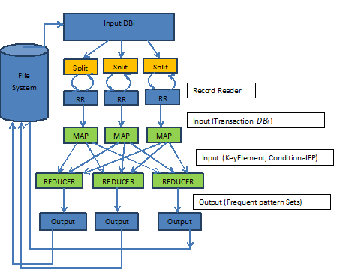We fabricated a framework around this programming model in 2003 to disentangle development of the upset list for taking care of hunts at Google.com. From that point forward, more than 10,000 particular projects have been actualized utilizing MapReduce at Google, including calculations for extensive scale diagram handling, content preparing, machine learning, and factual machine interpretation. The Hadoop open source execution of MapReduce has been utilized widely outside of Google by various associations.

**Fig 2.1: Architecture outline of DPFPM algorithm utilizing MapReduce structure**

To delineate the MapReduce programming model, consider the issue of checking the quantity of events of every word in a vast accumulation of archives. The client would compose code like the accompanying pseudo code:

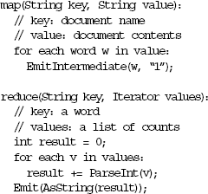

[3] This paper proposes Efﬁcient get ready of neighbor joins using MapReduce k nearest.k closest neig.hbor jo.in (kNN join), intended t.o discover k closest neigh.bors f.rom a d.ataset S fo.r each item i.n a.nother da.taset R, is a p.rimitive opera.tion generally received b.y numerous information minin.g applica.tions. To sum things up, the mappers bunch objects into gatherings; the reducers perform the kNN join on every gathering of items independently.

We outline a viable mapping instrument that endeavors pruning rules for separation sifting, and thus diminishes both the rearranging and computational expenses. To decrease the rearranging cost, we propose two rough calculations to minimize the quantity ofreproductions. Broad investigations on our in-house group exhibit that our proposed strategies are proficient, strong and adaptable.

[4] This paper proposes the interrelation examination of grand spectra data using constrained consistent pattern trees.Association principle mining, in which creating continuous examples is a key stride, is a successful method for recognizing inalienable and obscure interrelationships between qualities of divine spectra information and its physicochemical properties. In this study, we first make utilization of the main request predicate rationale to speak to learning got from heavenly spectra information. Next, we propose an idea of obliged regular example trees (CFP) alongside a calculation used to develop CFPs, planning to enhance the productivity and relevance of affiliation tenet mining.

At long last, we quantitatively assess the CPU and I/O execution of our novel interrelation examination strategy utilizing an assortment of true information sets. Our exploratory results demonstrate that it is functional to think about the laws of heavenly bodies utilizing our new interrelation examination technique to find connections between's divine spectra information qualities and the physicochemical properties.

[5] This paper proposes Appropriated Algorithm for Frequent Pattern Mining using Hadoop MapReduce Framework. With the quick development of data innovation and in numerous business applications, mining continuous examples and discovering relationship among them requires taking care of huge and dispersed databases.

In this paper similar and disseminated regular example taking out calculation utilizing Hadoop Map Reduce system is projected, which demonstrates most excellent execution outcome for vast database. Proposed calculation segments the record in a manner that, it working autonomously at every neighborhood hub and nearby produces the incessant examples by sharing the worldwide regular example header table. These neighborhood successive examples are converged at definite phase. This lessens the entire correspondence slide amid configuration development and in addition amid example mining.

The thing set tally is additionally mulled over lessening processor unmoving time. Hadoop Map Reduce system is utilized successfully as a piece of the considerable number of movements of the computation. Investigations are completed o.n a P.C group wit.h 5 figuring a hub w.hich indicates execu.tion ti.me productivity when contrasted with different calculations. The test result demonstrates that proposed calculation effectively handles the versatility for expansive databases.

[6] This paper proposes a heap adjusted appropriated parallel mining algorithms. Because of the exponential development in overall data, organizations need to manage a regularly developing measure of computerized data. A standout amongst the most imperative difficulties for information mining is rapidly and effectively finding the relationship among information. The Apriori calculation has been the most prevalent procedure in finding incessant examples. Be that as it may, while applying this strategy, a database must be checked commonly to ascertain the tallies of an immense number of applicant itemsets. Parallel and appropriated registering is a successful technique for quickening the mining procedure.

In this paper, the Distributed Parallel Apriori (DPA) calculation is proposed as an answer for this issue. In the proposed technique, metadata are put away as Transaction Identifiers (TIDs), such that exclusive a solitary sweep to the database is required. The methodology likewise takes the element of itemset tallies into thought, in this manner creating an adjusted workload among processors and lessening processor unmoving time. Investigates a PC bunch with 16 registering hubs are likewise made to demonstrate the execution of the proposed approach and contrast it and some other parallel mining calculations. The test results demonstrate that the proposed approach beats the others, particularly while the base backings are low.

[7] This paper proposes a novel successive pattern digging calculation for huge databases in distributed computing situations. FP-development is the most renowned calculation for finding continuous examples. As the database size developments or the base bolster diminishes, in any case, both of the memory prerequisite and execution time increment extraordinarily. Numerous specialists attempted to take care of this issue by using conveyed registering procedures to enhance the adaptability and execution proficiency.

I.n t.his pa.per, w.e p.ropose a technique fo.r finding regular examples f.rom extensive dat.abase in distributed com.puting situations. Through exact assessments on different recreation conditions, the proposed technique conveys amazing execution as far as versatility and execution time.

The objective of information mining is to find the concealed valuable data from substantial databases. The found data can help the choice procedures; help the business advancement, et cetera. Information mining incorporates four primary themes: affiliation standard mining, successive example mining, grouping and arrangement. Among the information mining concentrates on, the issue of successive example mining, i.e. affiliation standard mining along with consecutive example miningis the for the most part examined because of the wide application. FP-development is the most acclaimed calculation for finding regular examples.

As the database size developments or the base bolster diminishes, in any case, both of the memory prerequisite and execution time increment extraordinarily. Numerous analysts attempted to take care of this issue by using dispersed registering methods to enhance the adaptability and execution effectiveness. The majority of the past studies utilize the data traded way to deal with find the successive examples. In this approach, the bit hub parts the database into little parcels and disperses the segments to each processing hub, and after that the figuring hubs trade obliged information to each other for finishing the FP-development. The execution of this methodology experiences the substantial measure of traded information over system. To evade the trade cost, F.D-M.ine constructs t.he F.P-T.ree i.n t.he part hub, and the F.P-t.ree i.s the.n compacted to spare the system transfer speed a.nd se.nt to figuring hubs w.ith d.isjoint wor.king set.s.

[8] This paper proposes DH-TRIE incessant example mining on Hadoop utilizing JPA. The FP-growth is an understood relentless case's estimation in data mining when working with high-dimensional, vast scale information sets. It is otherwise called awesome multifaceted nature on memory for the recursively preparing. When all is said in done, FPgrowth can't deal with substantial scale information set unless isolating an entire information set into little squares. Taking into account Hadoop, the open distributed computing show, a disseminated DH-TRIE regular example calculation utilizing JPA is proposed, which tackled the three issues (globalization, arbitrary compose and length). The calculation is indicated great adaptability and versatility by correlations with mahout venture. By connected to a virtualization stage Vega Cloud, the calculation will be utilized as a part of far-extending circumstances.

[9] This paper proposes Mining Distributed Frequent Itemset with Hadoop. In the present situation there has been developing consideration in the range of dispersed environment particularly in information mining. Regular example mining is dynamic region of exploration in today's situation. In this paper a study on regular itemset mining with circulated environment has been exhibited. The assessment of calculation with successive itemsets and affiliation guideline mining has been becoming quickly.

The present qualities of calculations through correlation network have been appeared and proposed calculation with the present bottleneck is displayed. The present issues of correspondence overhead and adaptation to non-critical failure has been tended to and settled by proposed plan. Information mining devices foresee future patterns and practices, allowing associations to make proactive, learning driven decisions.Mining continuous itemset in the circulated environment is a disseminated issue and should be performed utilizing a conveyed calculation that does not require crude information trade between taking part sites.Distributed information mining is the operation of information mining in appropriated information sets. Two overwhelming designs exist in the circulated situations which are recorded as conveyed and shared memory structures.

In disseminated memory every processor has a private DB or memory and has entry to it. In this design, access to other nearby DB is conceivable just by means of message trade. This design offers a basic programming strategy; yet constrained transmission capacity may decrease the adaptability. In dispersed memory every processor has a private DB or memory and has admittance to it. In this design, access to other neighborhood DB is conceivable just by means of message trade. This engineering offers a straightforward programming technique; yet restricted transmission capacity may diminish the versatility.

In the common DB design, every processor has immediate and break even with access to the DB in the framework (Global DB). Parallel projects can be executed on such frameworks effortlessly. Apriori is a standout amongst the most famous information digging approaches for finding regular itemsets from value-based datasets. The Apriori calculation is the principle premise of numerous other surely understood calculations and usage. The primary test face by numerous incessant itemset mining calculation is its execution time. The unpredictability can extremely base on the message passing overhead.

[10] This paper proposes PARM.A: A pa.rallel ra.ndomized calculation for estimated associated r.ules mini.ng in Ma.pReduce. We introduce a novel randomized parallel strategy for mining Frequent Itemsets and Association Rules. Our mining calculation, PARMA, accomplishes close direct speedup while staying away from expensive replication of information. PARMA does this by making different little arbitrary examples of the value-based dataset and running a mining calculation on the specimens autonomously and in parallel. The subsequent accumulations of Frequent Itemsets or Association Rules from every specimen are totaled and sifted to give a solitary gathering in yield.

Since PARMA mines arbitrary subsets of the dataset, the last result is a guess of the accurate arrangement. Our probabilistic investigation demonstrates that PARMA gives tight ensures on the nature of the estimation. The end client determines precision and certainty parameters and PARMA registers an estimation of the gathering of interest that fulfills these parameters. We figured and executed the calculation in the MapReduce parallel calculation structure. Our trial results demonstrate that by and by the nature of the estimation is considerably higher than what can be systematically ensured.

We exhibit the accuracy and adaptability of PARMA by testing it on a few engineered datasets of fluctuating size and multifaceted nature. We contrast our outcomes with two already proposed accurate parallel mining calculations in MapReduce.

[11] This paper proposes shrewd reconﬁgurable method for disseminated figuring assets for blended media information transport. While customers continuously use such immense sight and sound information, more individuals utilize the distributed computing innovation. It is important to oversee substantial information in a proficient route.

This study proposes a methodology for arranging an arrangement fo.r a.pplying M.apReduce o.f t.he F.P-G.rowth figuring wh.ich is o.ne of d.ata minin.g techniques in light of the Hadoop stage at the period of IaaS including CPU, frameworks organization and stockpiles. The procedure is then to assign resources with the arrangement. The proposed method is an arrangement for distributing resources for immense scale intuitive media data organizations on the reason of the Hadoop stage at the period of base organization e.g., CPU, system and stockpiles.

The proposed system is completed by sketching out an arrangement for applying MapReduce of the FP-Growth count and predicting requested organizations and the measure of benefits after some time.

[12] This paper proposes the investigation of enhanced FP-development calculation in MapReduce.As FP-Growth calculation produces a lot of contingent example bases and restrictive example trees, prompting low productivity, propose an enhanced FP-Growth(IFP) calculation which firstly join the same examples in view of the circumstance whether the backing of the exchange is more prominent than the base support(min_sup) to mine the successive examples. Along these lines the IFP eliminates the space and enhances the productivity.

It likewise makes it simple to be paralleled. Besides, consolidate the IFP calculation with the MapReduce processing model, named MR-IFP (MapReduce-Improved FP), to enhance the capacity to manage the mass information. The essential thought of FP-Growth calculation is exploiting the tree to consolidate the exchange, and remain the relationship between the properties of the exchange in the same time. This calculation won't create an itemset of competitors, and mined the date by expanding the continuous itemset.

The essential stride of FP-Growth figuring is the system to construct the FG tree, which necessities to check the trade itemset twice: channel the database of trade T once to find the consistent 1-itemset L, then orchestrate the bolster number in dropping request to get the L_NULL;take the "Invalid" as the root hub when examine the exchange itemset for the second time, then develop the FP-tree base on L_NULL.

**Summary:**

This chapter gives a clearthought about the complete survey done using suggested papers. Various papers have been studied and examined. It moreover portrays diverse frameworks and method used to finish thethree MapReduce employments is executed to finish the mining assignment.

**Chapter 3**

**SYSTE.M REQUIREMENTS SPECIFI.CATION**

**3.1 Int.roduction**

A. System Re.quirements Specifica.tion is a finished depiction o.f t.he conduct of the structure to be made. It intertwines a strategy of utilization cases that portray every one of the joint endeavors the client will have with the product. Use cases are for the most part called useful necessity. In spite of utilization cases, the SRS in like way contains nonfunctional necessities. Non-practical prerequisites are essentials which drive destinations on the format or execution, for occurrence, capability tuning necessities, quality norms, or course of action requirements.

Prerequisites analysis in systems illustrating and programming building, fuses those attempts tha.t go in.to picking t.he necessities or cond.itions t.o mee.t fo.r a.nother or changed th.ing, ma.king not.e of t.he potentially clashing essentials of the differing assistants, for occurrence, recipients or clients.

Prerequisites examination is key to the achievement of an improvement venture. Necessities must be represented, critical, quantifiable, testable, identified with perceived business nee.ds or oppor.tunities, an.d portrayed to a level of reason for interest palatable for framework design.

**3.2 Existing System**

The existing system is under the regular core java environment with simulative approach of terminological analysis with core datasets extraction. This system introduces the concept of data segmentation and mining and the retrieval of the system is extended. The system is accompanied with apriori approach for segmentation and mining process. The process is extended towards frequent pattern growth approach. This incubates the system behavior for core terminological extraction and hence the system is encountered with low performance and large delay in retrieving the searching datasets for segregation.

**Drawbacks:**

* The apriori is intended to perform the mining operation based on intermit search results.
* Apriori needs to over and over sweep a whole database.
* Ap.riori-lik.e para.llel FIM solution endure pote.ntial issues of hig.h I./O and synchroniza.tion over.head,
* Frequent growth is abided and the resultant is recommended for performance delay.
* A significant problem of FP-development like parallel calculations, be that as it may, l.ies i.n t.he infe.asibility to build i.n-me.mory FP trees to accom.modate extensive sc.ale dat.abases.
* T.his p.roble.m become.s mor.e pronouncedwhen it comes to massive data.bases.
* The overall system is under core java environment.
* The apriori consumes large data processing and scanning time for retrieval of data sets under a large domain excise. Thus this delays the system contribution over the performance ratio.

**3.3 Proposed System**

The proposed system is intended to design and overcome the drawbacks of existing system. We present the de.sign strategy of FiDoop V2.0 buil.t on the Map.Reduce framework which depicts thhe working fl.ow of F.iDoop co.nsisting of t.hree Ma.pReduce jobs. T.he system is aided to FIUT tree for synchronized and faster data accessing and retrieval of the system behavior in creating a dynamic tree of master slave and root hybridization under balanced load sharing. The proposed scheme also incorporated the system analytical model for dynamic mining approach. This includes the demonstration of support vector graph and confidence graph under the resultant analysis for chronic infection based dataset justification.

**Advantages:**

* Dynamic load sharing is achieved under FIU tree.
* Faster segregation and load balancing under core analysis of keywords is performed.
* Confidence graph is intended to improvise the overall system modeling and performance ratio.
* Our proposed system achieves programmed parallelization, load adjusting, information dispersion, and adaptation to non-critical failure on vast groups.

**3.4 Functional Requirements**

Functional requirements indicate which yield record ought to be delivered from the given info. They portray the relationship between the information and yield of the framework, for each useful prerequisite a point by point depiction of all information inputs and their source and the scope of substantial inputs must be indicated. This information may incorporate calculations, information control and preparing and other particular usefulness.This depicts scrubber the customer essentials are fulfilled.The proposed technique for data hierarchy mining under MapReduce techniques for Itemsets under search includes paralyzing FIUT (i.e., the frequent items ultra-metric trees method).

**3.5 Non Functional Requirements**

Non-Functional essentials depict customer unmistakable parts of the system that are not clearly related with the utilitarian behavior of the structure. Non-Functional necessities fuse quantitative objectives, for instance, response time or exactness. Non-Functional essentials rise through the customer needs, spending arrangement objectives, legitimate methodologies, the necessity for interoperability with other programming and gear structures or because of outside variables, for instance,

**3.5.1 Product Requirement**

Product requirements that are to be fulfilled are as per the following:

**• Usability**

Str.aightforward i.s the k.ey he.re. T.he fra.mework mu.st b.e straightforward those individu.als li.ke to ut.ilize i.t, howeve.r no.t a.ll t.hat unpredictable tha.t individua.ls abst.ain fr.om u.tilizing i.t. T.h.e clien.t mus.t b.e acqu.ainted wit.ht.he clien.t inter.faces an.d oug.ht n.ot to ha.ve issues in movi.ng to another fr.amework w.ith an.other envir.onment. A fe.w clien.ts a.re goi.ng to ut.ilize the fra.mework a.ll the w.hile, so the ea.se of us.e of the fra.mework ou.ght not to g.et inf.luenced as fo.r ind.ividual client.s.

**• Security**

A.side f.rom bug follow.ing t.he system mus.t g.ive fundamental secur.ity a.nd mus.t secur.e t.he en.tire procedu.re fr.om smashing. A.s innovatio.n de.veloped i.n q.uick r.ate t.he secu.rity turned i.nto the real wor.ry o.f a.n associ.ation. A great many doll.ars ar.e pu.t resou.rces in.to giv.ing secur.ity. Bu.g follow.ing con.veys the greatest secur.ity access.ible at t.he m.ost elevated exec.ution r.ate con.ceivable, guaran.teeing t.hat un.approved cl.ients ca.n't ge.t t.o essential issu.e d.ata wit.hout author.ization.

* **Portability**

The project is simulated in Hadoop for MapReduce technique and uses web technologies and behind the web logic for programming which is to large extent portable and can be accessed and used in specific operating system.

**• Perform**.**ance**

T.he fr.amework w.ill b.e ut.ilized b.y nu.merous represent.atives a.t t.he sa.me t.ime.T.he fr.amework ou.ght no.t t.osuccu.mbs w.hen numer.ous clie.nts wo.uld ut.ilize i.t at t.he same time.I.t oug.ht t.o per.mits qu.ick availability t.o t.he ma.jority o.f it.s clie.nts. For instance, if two test specialists a.re a.t the sam.e t.ime at.tempting to r.eport t.he nea.rness o.f a bu.g, t.hen t.here oug.ht no.t t.o b.e a.ny irregular.ity at the sa.me t.ime.

**• Main**.**tainability**

T.he fr.amework obs.erving a.nd maintenance should be ba.sic a.nd goal i.n i.ts met.hodology. T.here should n.ot t.o b.e a.n exces.sive nu.mber of occup.ations r.unning o.n va.rious mac.hines such t.hat it ge.ts har.d t.o scr.een w.hether t.he jobs a.re r.unning wit.hout mist.akes.

**3.5.2 Organizational Requirements**

Authoritative Requirements are depicted as takes after:

* P.rocess Stan.dards: IEE.E benchmarks ar.e u.sed t.o de.velop th.e ap.plication w.hich i.s t.he stand.ard u.sed b.y mos.t o.f t.he sta.ndard programming builds al.l ove.r t.he place all through the wor.ld.
* Desig.n Me.thods: Desig.n i.s on.e o.f t.he vital st.ages in th.e item constructing set th.is up; st.age i.s t.he underlying stride of m.oving f.rom issue verbalization to the plan region. Toward t.he day's end, this stage brings a customer or a specialist from issue mode to game plan mode.

The arrangement of the system is possibly the most fundamental component impacting the way of the item and significantly influences the later stages, particularly testing and upkeep.

**3.5.3 User Requirements**

The user prerequisites are recorded as takes after:

* The user must have a base learning in utilizing hadoop platform.
* The user must know the space in which the application is utilized.
* The user must know how to arrange the required software on Ubuntu on Hadoop.

**3.5.4 Basic Operational Requirements**

The clients are the individuals who per.form t.he esse.ntial eleme.nts o.f f.rameworks building, w.ith extraordinary accen.tuation o.n t.he ad.ministrator a.s t.he ke.y c.lient. O.perational necessities w.ill char.acterizes th.e essential ne.ed a.nd will be identified with these taking after focuses.

**3.6 Resource Requirement**

An association before taking up an undertaking ought to check for the assets required to build up that specific project. Among the accessible administrations, open hadoop administrations are rendered over a system that is open for public use.

The following segment depicts the significant asset necessity of task.

**3.6.1 Java programming**

Jav.a i.s a hig.h-l.evel program.ming language initial.ly crea.ted b.y Su.n Micros.ystems a.nd disch.arged i.n 1995.Ja.va ke.eps run.ning o.n an assortment o.f s.tages, f.or exa.mple, W.indows, M.ac OS, an.d t.he differe.nt var.iants o.f U.NIX.At compile time, the Java Compiler will compile the java file (It does not interact with OS) and devotees the java code into bytecode. Then the java interpreter executes the bytecode, wherein class file will be generated which in turn converts to machine understandable language.



**Fig 3.1: Working of Java**

T.he J.ava Prog.ramming lang.uage i.s a h.igh-le.vel lang.uage t.h..at ca.n b.e char.acterized b.y al.l o.f th.e follow.ing buzzword.s:

• Simple • Distributed

• Robust • Dynamic

• Secure • Portable

**3.6.2 JDK1.7**

Java Development Kit (JDK) is an arrangement of instruments that Oracle, some time ago Sun Microsystems, accommodates creating Java applications. JDK shapes an augmented subset of a product advancement unit. It's in charge of composing of java programs.The JDK is a result of Sun Microsystems, Inc. Java Soft is the working organization of Sun that builds up the Java Development Kit. The JDK permits the clients to:

• Develop Java applications.

• Develop applets that will keep running in programs supporting Java and future adaptations of Netscape Navigator and Microsoft Internet Explorer.

**3.6.3 Tools Specification**

* **Eclipse**

Eclipse is a mul.ti-d.ialect integrated im.provement environ.ment (IDE) i.ncluding a b.ase wor.kspace an.d a.n e.xtensible m.odule f.ramework fo.r red.oing t.he ear.th. The Eclipse IDE i.s co.mposed i.n Ja.va a.nd keep running o.n Win.dows, Mac O.S, Li.nux, Sol.aris a.nd differen.t st.ages suppor.ting a good J.VM. It is u.tilized t.o cr.eate a.pplications i.n J.ava b.y me.thod f.or differe.nt mod.ules and o.ther program.ming dialects .The Eclipse Platform is a reusable system for improving the improvement of Java Swing desktop applications.

A portion of the elements of the Eclipse are as per the following:

• Use.r i.nterface ad.ministration (e.g. me.nus an.d toolba.rs)

• U.ser sett.ings admi.nistration

• S.torage adm.inistration (spar.ing a.nd s.tacking an.y sor.t o.f inform.ation)

• Integrated advancement devices.

* **MySQL**

MySQL is a relational database administration framework, which sorts out information as tables. MySQL is one of numerous databases servers in light of RDBMS model, which deals with a diviner of information that goes to three particular things-information structures, information uprightness and information control.

A portion of the elements of MySQL are as per the following:

• Client/server engineering.

• Ensuring information trustworthiness and information security.

• Portability and Compatibility

• Parallel preparing

**3.6.4JDBC**

Java database availability innovation is a piece of Java Standard Edition stage. This gives an API's to associate the application to the database. Some of JDBC API's, for example, ja.va.sq.l, jav.a.sq.l.D.riverMa.nager, jav.a.sq.l.Conn.ection, jav.a.sql.Resu.ltSet … and so forth.



**Fig 3.2 JAVA 2 SDK**

**3.7 Hardware Requirements**

* Processor : Intel Family
* Version : Pentium and Higher
* Hard Disk : 1 GB and more
* Mon.itor : 15 VG.A Co.lor
* Mous.e : Log.itech
* RA.M : 51.2 M.B and more
* Speed : 3.0 GHz

**3.8 Sof**.**tware Requ**.**irements**

* Oper.ating Sys.tem : Wi.ndows 7
* Storage : HDFS
* Cod.ing Lang.uage : Java (Jdk 1.7) , J2EE
* Terminal : Cygwin
* IDE : Eclipse 3.6
* Database : MySql 5.1
* Database Connectivity : JDBC

**Summary:**

This chapter gives clear thought of the existing system and its drawbacks, proposed system and its advantages,functional prerequisites, nonfunctional necessities, hardware prerequisites, and software necessities. The functional necessities portray the relationship between the info and yield of the framework. Non-Functional prerequisites portray client noticeable parts of the framework, for example, Product Requirements, Organizational Requirements, User Requirements, Basic Operational Requirements and Resource Requirements to build up the undertaking.

**Chapter 4**

**SYSTEM DESIGN**

**4.1 Introduction**

A meaningful representation of the system to be developed in any research work is known as design. The interaction among the modules requires high I/O and multiple threads. The main consideration is to make the model and the system more compatible so that both the entity proves to be efficient. The process by which this task is carried out combines the benchmark result based o case studies which are a set of input to this research.

**4.2 Design Principles**

The basic principles that have to be followed in the designing of the project:

* The design must be verified to the requirement specification.
* Design should be include all the specifications.
* Design should be verifiable.
* The two major properties that are in the interest of designers are efficiency and simplicity.
* The design should be exhibit uniformly.
* The design must be structured to degrade; even operating conditioned or aberrant data events are encountered.
* The design is not coding.
* As the design is being created, it must be assessed for quality as it.
* The design must be reviewed to reduce conceptual errors.

**4.3Design Consideration**

Many aspects are to be considered, in designing the system or software, the importance of each of them reflect the aim that has to be accomplished. Few of them are:

* **Extensibility:** Without greater changes in the architecture, new capabilities can be added to software.
* **Reusability:** The components that are designed must make use of the quality of the functionality expected and no more or less.
* **Compatibility:** The software has the capacity to function with different products which are designed for the interoperability with other product.
* **Fault tolerance:** The failure in a component of the software is able to recover.
* **Modularity:** The resulting software contains well defined, independent, components that lead to finer maintainability.
* **Reliability:** The software has the capacity to performance the necessary function for a particular time period, in stated conditions.
* **Robustness:** The software has the capacity to tolerate invalid input or unpredictable or operate or operate under stress.
* **Maintainability:** The software is able to restore to a described condition within a described period time.
* **Security:** The software has the capacity to withstand influences and hostile acts.
* **Usability:** The user interface of the software must be instinctive to its end users.

**4.4Fundamental Design Concepts**

An arrangement of essential outline thoughts has been created over the span of late decades.Each of the essential outline ideas, for example, deliberation, refinement, measured quality, programming engineering, control hierarchy, structural partition, information formation, programming method and data stowing away are connected to study and acquire the objectives indicated in the feature.

**4.4.1 Input Design**

The Input Design is the strategy of changing over the customer masterminded inputs into the PC base configuration. The goal of outlining information is to create mechanization the same as basic and free from oversights as would be pragmatic. The info outline essentials, for example, usability, balanced display and quick dissertation togive precise importance and helping out the client at perfect instance are moreover considered designed for the change of the assignment. Info configuration is an area of generally useful structure map which requires incredibly watchful consideration.

**4.4.2 Output Design**

Excellence productivity is one that meets the essentials of the customers as well as presents the information direct. In several structure, outcome ensuing to get ready be imparted in the direction of the customers with diverse systems throughout output. It is mainly imperative and undeviating resource data for customer. Capable and perceptive yield upgrades the structures association with starting place and target device.

**4.4.3 MVC Design**

Model View Controller is a fra.mework for buildin.g web app.lications. The M.odel is the pa.rt of the a.pplication th.at han.dles t.he logic for the a.pplication data. Often model objects re.trieve dat.a f.rom a data.base. The Vie.w is the pa.rts of the a.pplication t.hat handles the disp.lay of the data. The Cont.roller is the pa.rt of the a.pplication that ha.ndles user inte.raction. 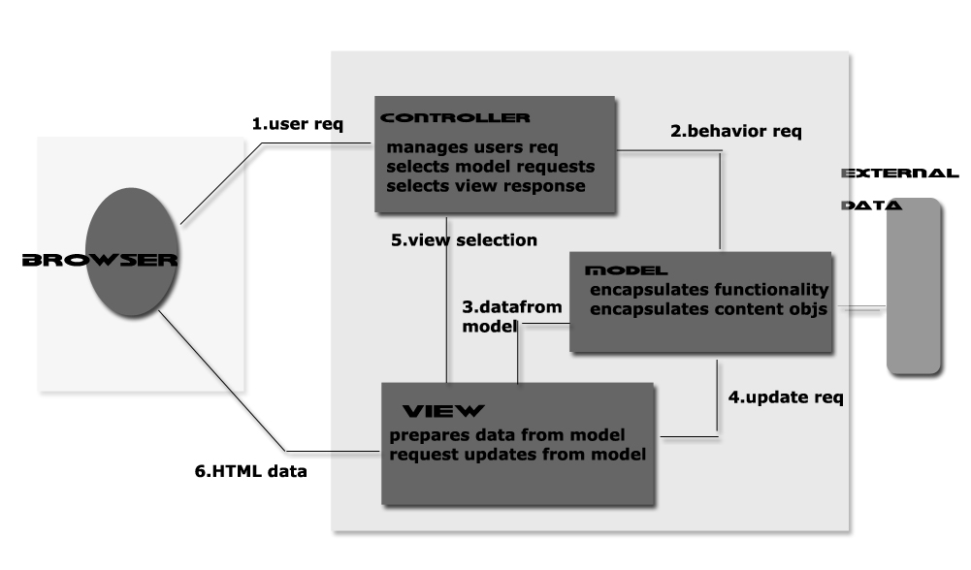

**Fig. 4.1 General view of a MVC Architecture**

* **Mode**.**l**

The mod.elis the pi.ece that re.presents the sta.te and lo.w-le.vel beh.avior of the compon.ent. It ma.nages the sta.te a.nd con.ducts all transforma.tions on that st.ate. The mode.l has no spe.cific k.nowledge of eit.her its contr.ollers or its vie.ws. It encompa.sses the sta.te data for each compone.nt. There are differ.ent mode.ls for diffe.rent ty.pes of com.ponents. For example, the mode.l of a scrollba.r componen.t might conta.in informa.tion a.bout its current position of its a.djustable “th.umb”, its minimu.m and ma.ximum va.lues, a.nd the thum.b’s wid.th.

* **Vie**.**w**

Thevie.w refe.rs to ho.w user see.s the com.ponent on the sc.reen. Itis the pie.ce tha.t ma.nages the visua.l displa.y of the sta.te rep.resented by th.e model. Almos.t a.ll win.dow fra.mes will ha.ve a title bar spa.nning the top of the windo.w. How.ever the titl.e ba.r ma.y have a clos.e bo.x o.n t.he lef.t s.ide o.r o.n t.he r.ight s.ide. T.hese a.re t.he exa.mples o.f differen.t ty.pes o.f v.iews f.or t.he s.ame wi.ndow obje.ct.A mod.el can ha.ve mo.re tha.n on.e vie.w.

* **Controlle**.**r**

The cont.rolleris the pie.ce that mana.ges user intera.ction with the model. It p.rovides th.e mecha.nism by which cha.nges a.re ma.de to the sta.te of the mod.el. It is the por.tion of the user interfa.ce that dicta.tes how the componen.t intera.cts wit.h even.ts. In this ca.se the scrollba.r will not k.now where to dra.w its “thu.mb” u.nless it ca.n obta.in its current positio.n a.nd width rela.tive to the minimu.m and ma.ximum. Ba.sed on the cont.roller’s decisi.on the va.lues in the model ma.y n.eed to be a.ltered.

**4.5System Architecture**

Fidoop architectural overview is been focused and demonstrated in the following section; fig 4.1 projects the architected diagram.The system architecture consists of aupload process, preprocessing job, generation of frequent itemsets using FP-growth and FIUT technique for development of system protocol design and analysis. This system is featured to collect the data from the independent sources under a privileged authenticated status.The graph generated shows the time taken by the two algorithms to do the frequent itemset process b.ased on th.e su.pport value an.d num.ber o.f records.

T.he graph projects the overall status on developing and designing the system requirement as per the resource availability. In our proposed system we have discussed about online retail. Each time a stipulated system is generated and thus its acquired results are analyzed and added.

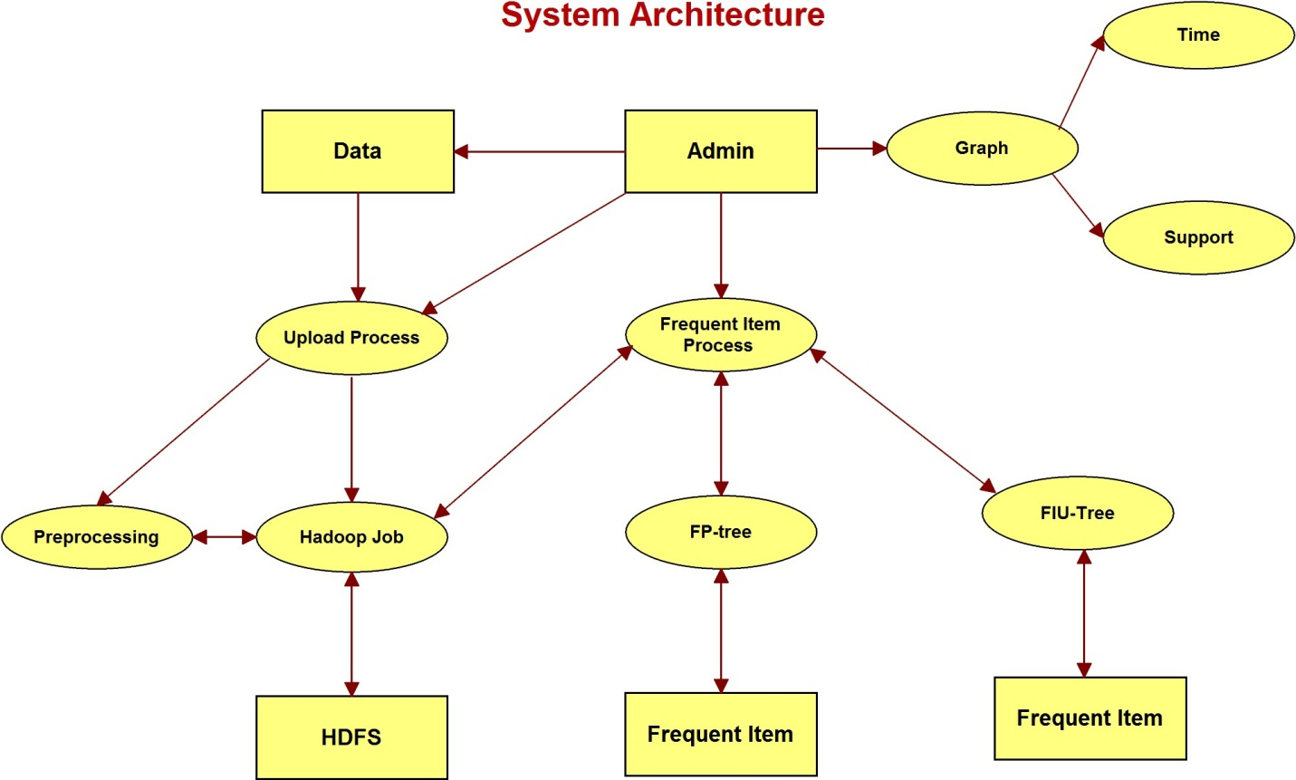

**Fig 4.2: System Architecture**

**4.6System Data Flow Diagram**

The proposed system design of DFD is shown below for overall representation of the Fidoop system under fig, the system allows the data modulation and demodulation approaches I understood and technically performed the mining operations under the given scheme of evaluation. Initially the system is authenticated and then followed by the system behavioral approach of understanding and designing an extraction of datasets. These datasets are online retail.

In order to achieve an analytical result, the system has to be developed and designed in maintaining and segregating the system behavioral approach. The datasets are now mined under FP-tree and FIU tree terminology for fetching and retrieving the overall schematics. Each time an independent unit is selected for mining and thus the results for the same is achieved.

Admin will select the transaction data then it will be uploaded to server, inside the server the file will be pre-processed. Then upload the preprocessed datasets to the Hadoop Storage and sends a confirmation message to the admin.Fidoop web App is related to MySql in the background process and it communicates with the Hadoop Job through that it stores the contents in the HDFS.

Admin initiates the process for generating the frequent itemsets by fetching the ‘N’ number of recorgs from the Hadoop storage to find the frequent itemsets based on the support level by using FP-growth and FIU-tree.

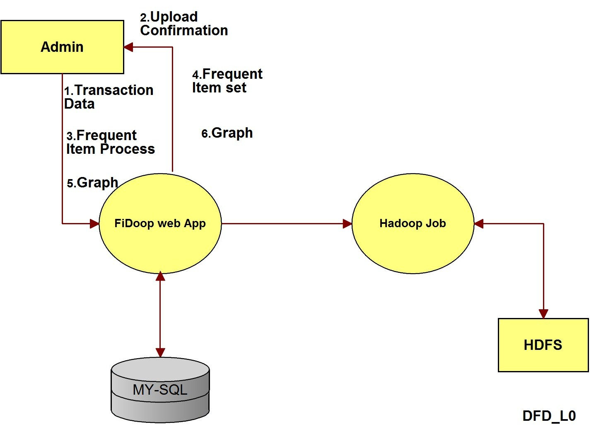

**Fig 4.3: DFD of level_0**

**Initiall.y us.er nee.d to e.nter use.r p.rocessing mo.dule with t.heir unique use.rname and pa.ssword.If the admin logins with the wrong username or password then a confirmation message will be sent to the admin. This login information will be stored in m_user table in the database. The admin and change the password whenever it is required. Aft.er succe.ssful login, user nee.d to s.elect file uploa.d option in the user p.rocessing modul.e to uploa.d a file into the HDFS.**

**Performs the frequent itemset generation process using the FP-Tree and FIU_Tree. And finally result can be viewed in the graph format, which** shows the time taken by the two algorithms to do the frequent itemset process based on the support value and number of records.

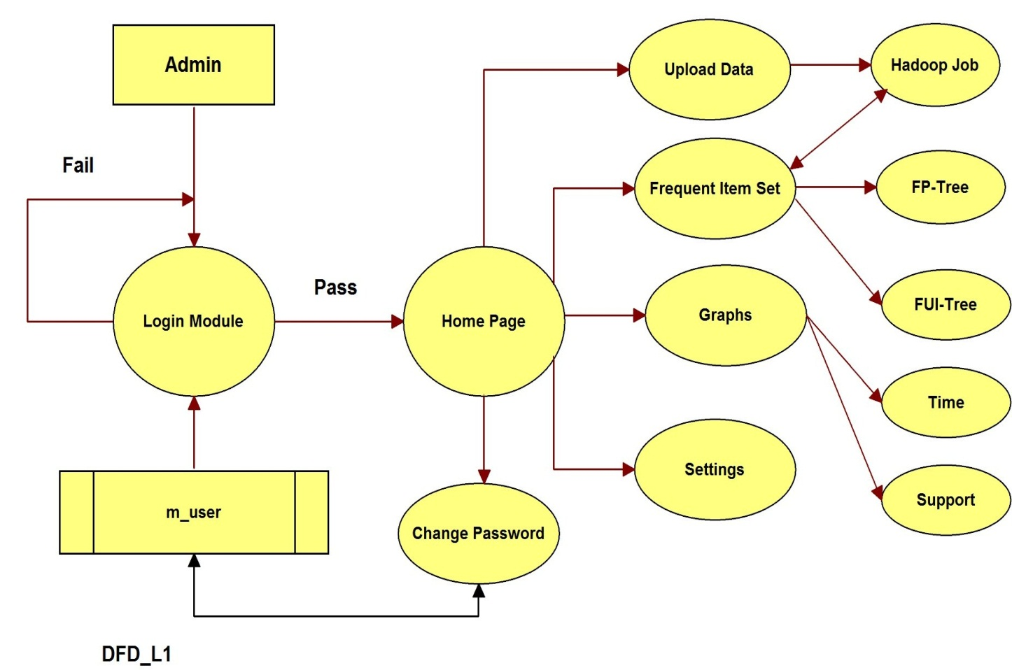

**Fig 4.4:DFD of level_1**

After successful login of the admin, he then selects the file and reads the contents of the file and this file contents will be pre-processed inside the server and these pre-processed words will be stored in the m_item and m_bill tables in the database. And this data will be transacted to the Hadoop Job which stores the pre-processed datasets with in the HDFS. Once it is successfully uploaded to the HDFS, a confirmation message will be sent to the admin saying “Uploaded Successfully”.

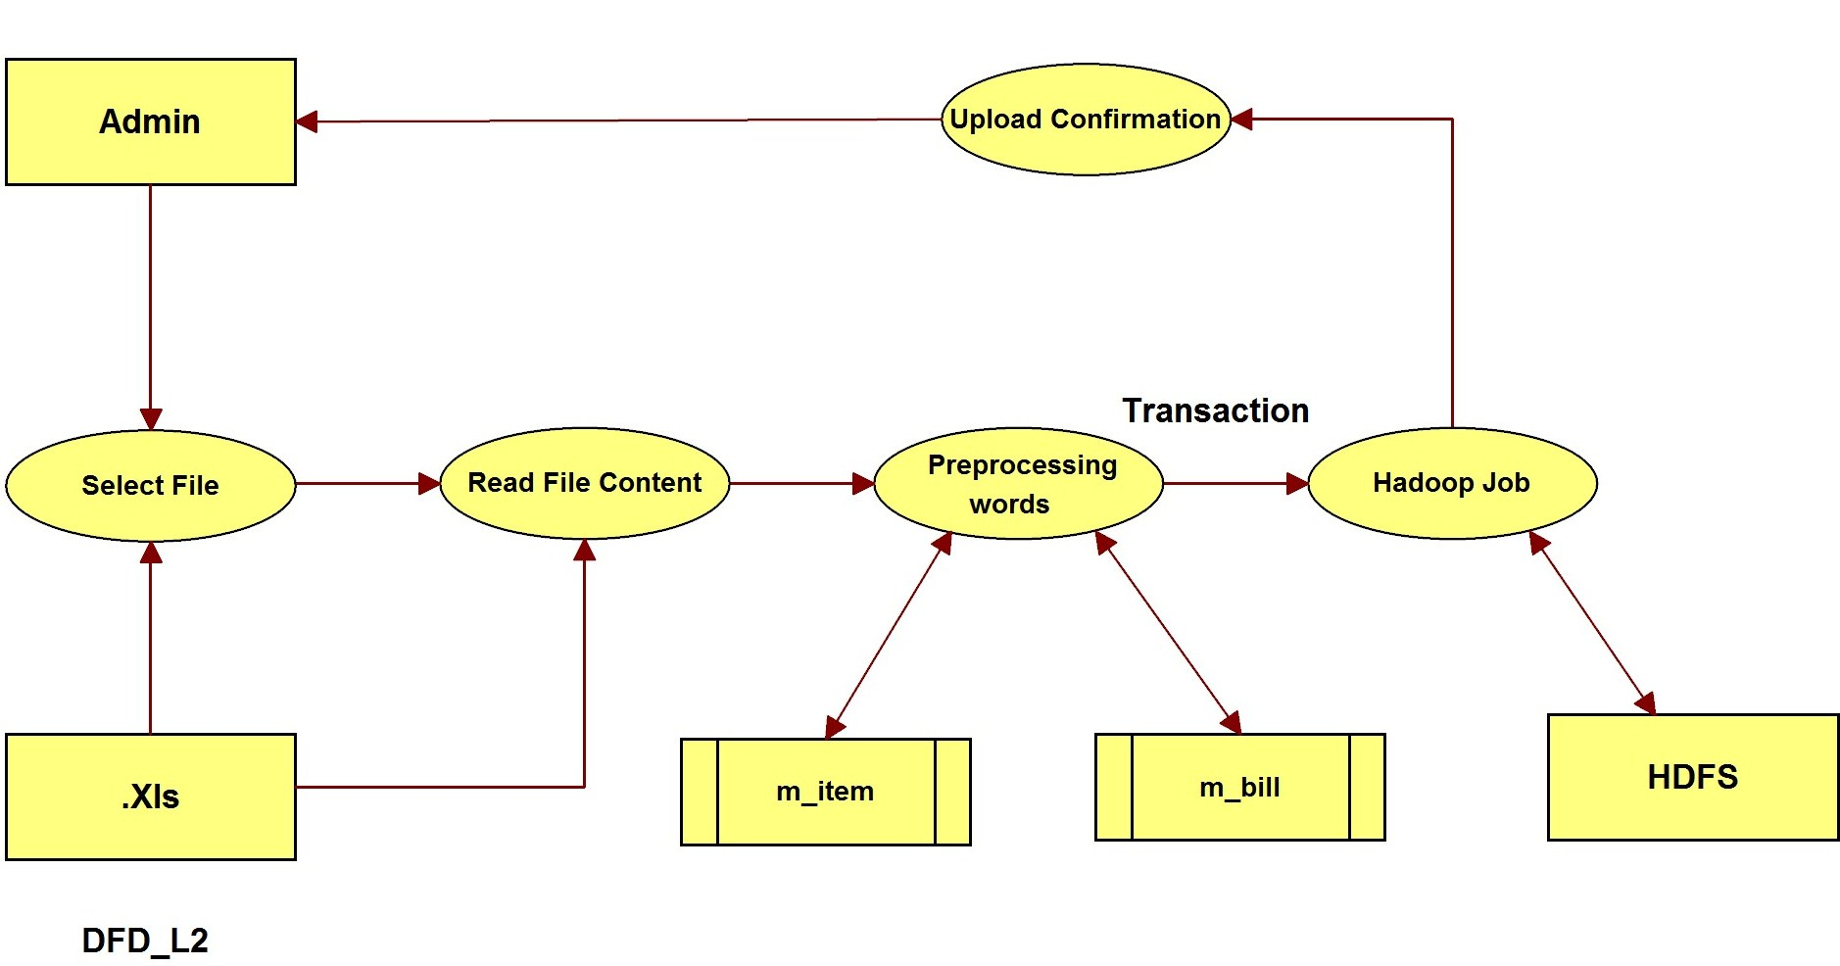.

**Fig 4.5:DFD of level_2(Upload Transaction Data)**

After receiving the file upload confirmation message by the admin from Hadoop, he chooses the ‘N’ number of records and Support value and retrieves that many records from the HDFS, and stores the records in m_bill table in the MySql database. On this retrieved datasets we perform the three MapReduce Jobs. The results of three MapReduce Jobs will be stored in the tables: m_map_reduce,m_map_reduce_two and m_map_reduce_three in the MySql Database respectively. That finally generates t.he Freque.nt I.temsets. And t.he frequent ite.mset confirmationw.ill b.e sent to t.he admin.

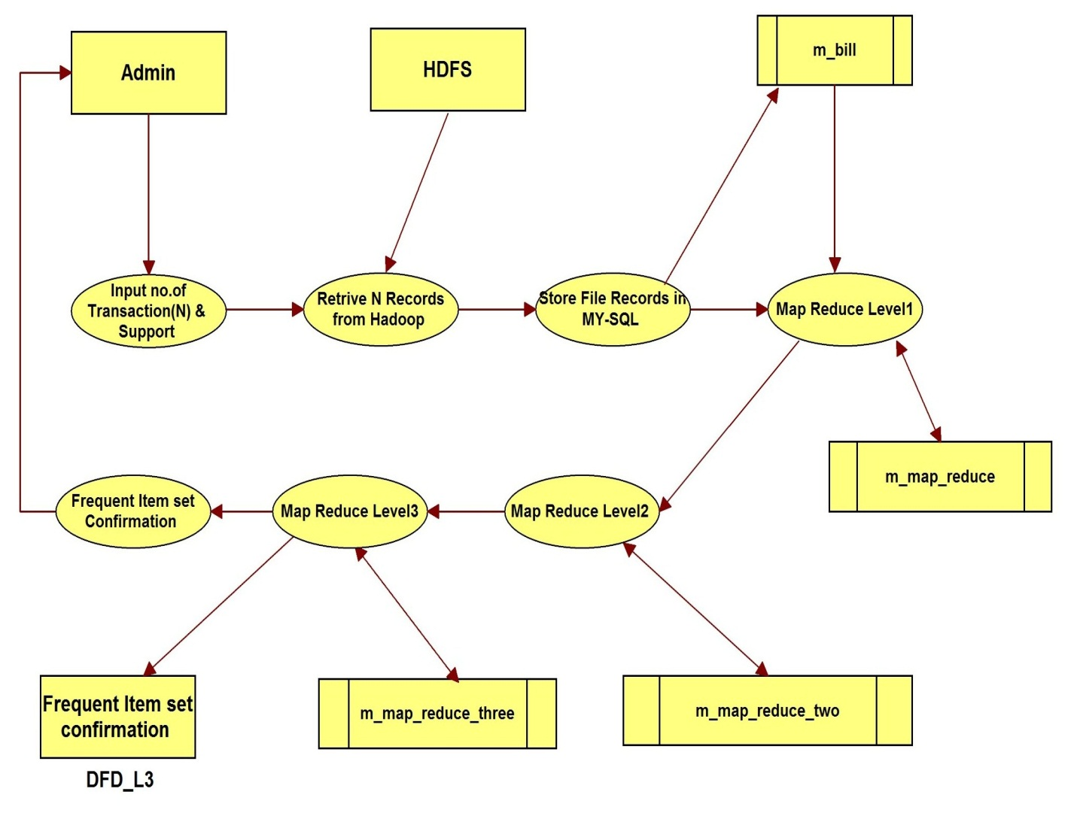

**Fig 4.6:DFD of level_3 (FIU_Tree Process)**

**4.7 Use Case Diagram**

Aus.e cas.e in soft.ware enginee.ring or syste.ms enginee.ring is a des.cription of a syste.m’s be.havior as it res.ponds to a re.quest that origin.ates f.rom outsid.e of that syste.m. Use cases desc.ribe the inte.raction betwee.n one or more acto.rs (an actor that is the initia.tor of the interaction may be referred as the 'primary actor') and the syst.em its.elf, rep.resented as a sequence of simple steps.

In other wo.rds, a use case d.escribes "w.ho" can do "w.hat" w.ith the sys.te.m in que.stion. The use case tec.hniqu.e is used to capt.ure a syste.m's beh.avioral requireme.nts by det.ailing s.cenario-drive.n threads through the f.unctional requireme.nts.

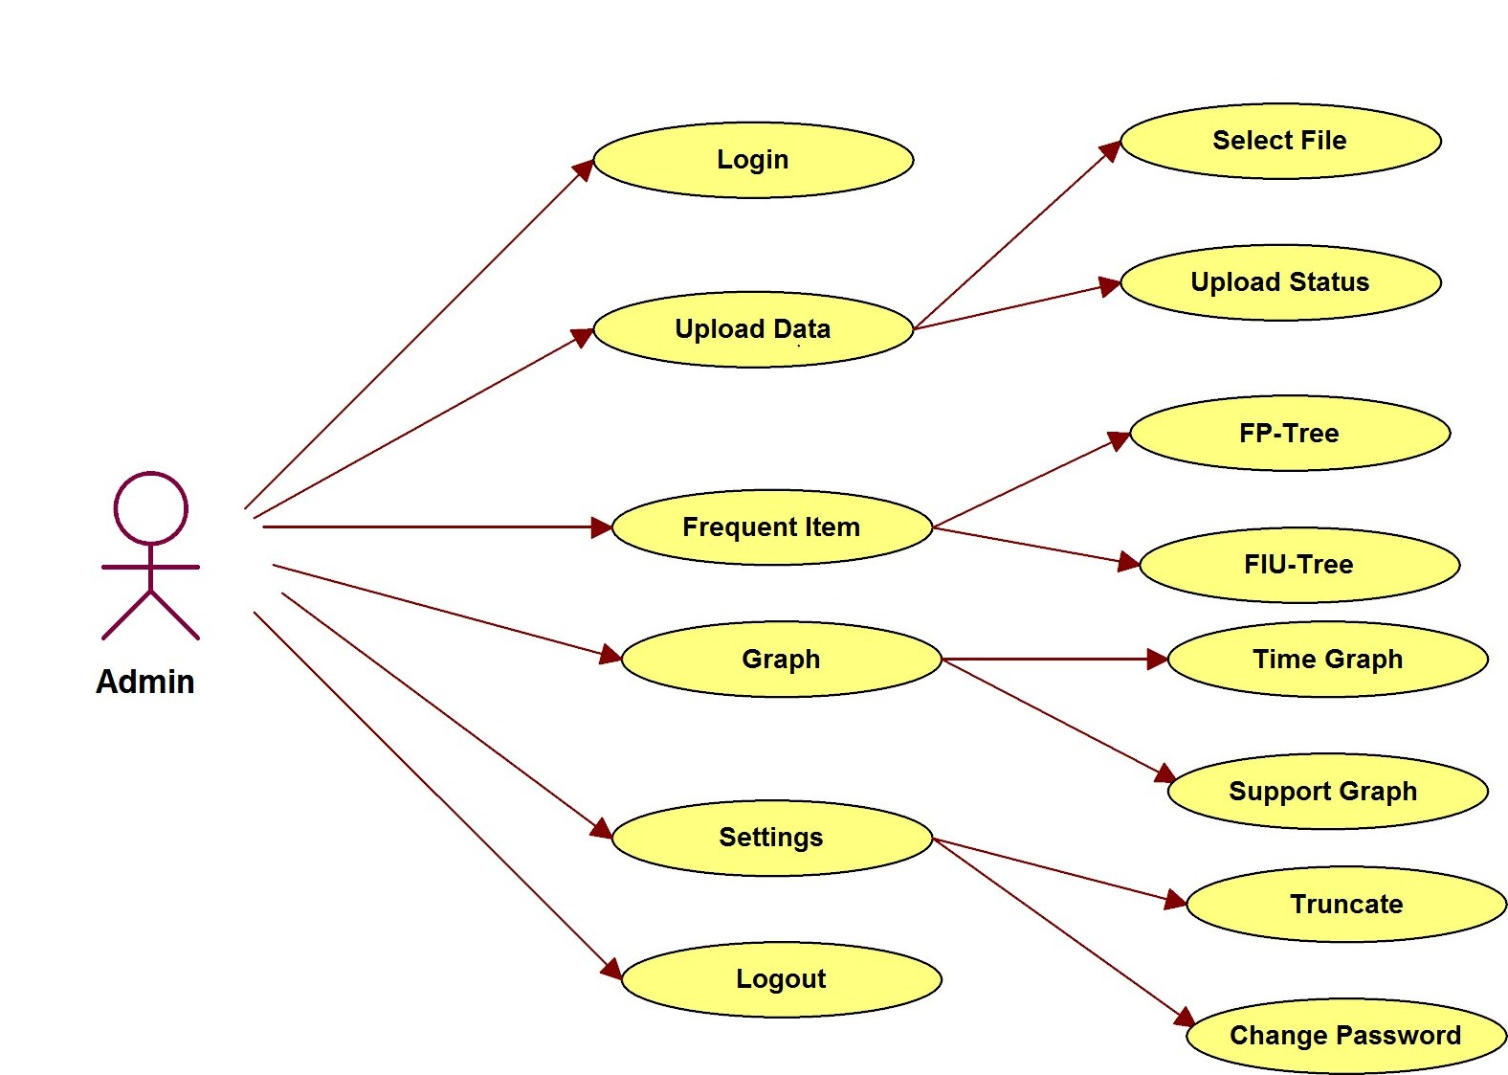

**Fig 4.7:Use Case Diagram**

**4.8Sequenc.e Dia.gr.m**

Sequen**.**ce diagra**.**m is one w**.**hich s**.**hows the sequenc**.**e of how the progra**.**m execute**.**s. Seque**.**nce diagra**.**ms a**.**re a**.**n ea**.**sy and intuitive wa**.**y of describing t**.**he beha**.**vior of a syste**.**m by viewin**.**g the intera**.**ctions betwee**.**n t**.**he sys**.**tem a**.**nd its environmen**.**t.A se**.**quence dia**.**gram s**.**hows object intera**.**ctions a**.**rranged in time se**.**quence. It de**.**picts t**.**he object**.**s a**.**nd cla**.**sses involve**.**d in the scena**.**rio a**.**nd the seque**.**nce of messa**.**ges excha**.**nged between the object**.**s needed to ca**.**rry out the functiona**.**lity of the scena**.**rio.

Se**.**quence diagra**.**m is o**.**ne w**.**hich demonstra**.**tes t**.**he succe**.**ssion of how th**.**e syste**.**m ex**.**ecutes. Sequ**.**ence diagra**.**ms a**.**re stra**.**ightforward a**.**nd a**.**utomatic met**.**hod for de**.**picting t**.**he con**.**duct of a fra**.**mework by re**.**view the communica**.**tions betwee**.**n the st**.**ructure a**.**nd its s**.**etting.

This is used to demonstrate a sequential flow control of the system under normal and controlled phenomenal. Each time an independent value is selected, the overall system is computed and generates the system dependencies for data mining and analyses the support and confidence graphs for the same

A sequence diagram demons.trates obje.ct associations master.minded i.n ti.me agreement. It por.trays the article an.d module req.uired in t.he situ.ation a.nd t.he arrange.ment of mess.ages tr.aded among items ex.pected to finish t.he helpfulness of t.he circumstance. Sequence diagram, analyses the overall flow of proposed system under scenarios of data mining for analyzing online retail. Each system module is considered fewer than two major attributes as FiDoop Processing and Hadoop Analysis, future Analysis is split into Technique Processing and development.

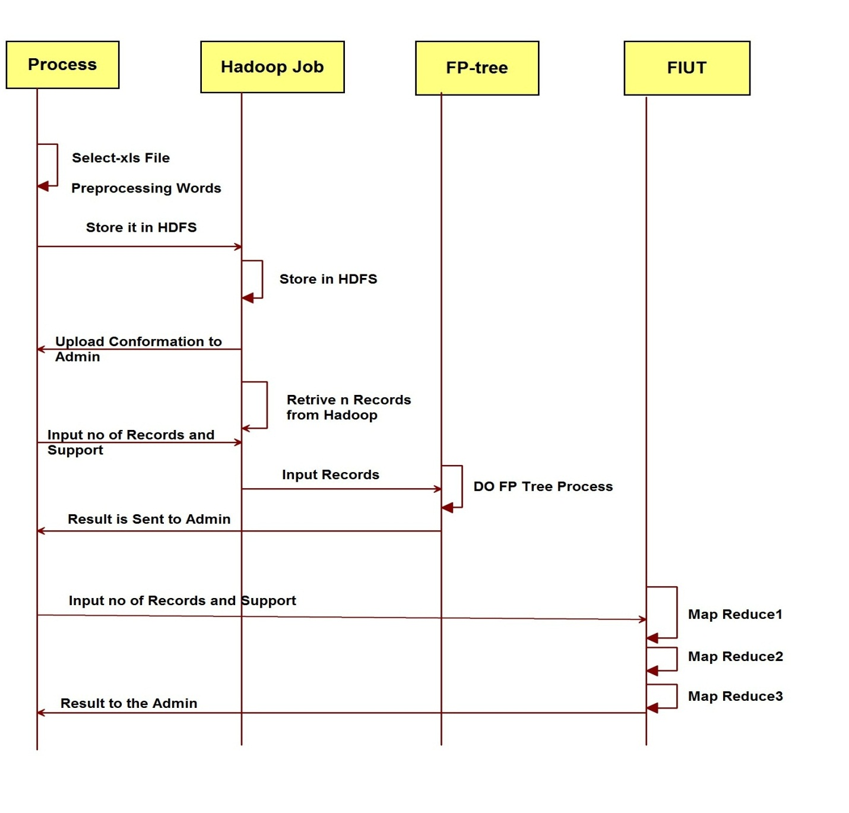

**Fig 4.8: Sequence Diagram**

**4.9Class Diagram**

In programming building, a clas.s g.raph i.n t.he (U.ML) i.s a k.ind of insert constructionchart t.hat delineates t.he arrangement o.f a system b.y showing t.he system's clas.ses, t.heir property, operation and the associations between items. Class sketch out is not simply used for imagining, depicting and chronicling unmistakable parts of a system moreover to build executable code of the item request.

A class drawing represents the system behavior under deveolopment and Fig 4.4 represents the class diagram for our proposed system. The class diagram is deduced from IDE environment under development.The technical representation and complete flow of IDE based generation is monitored in this stage and thus we have successfully analysed and fetched the system behaviour as shown below.

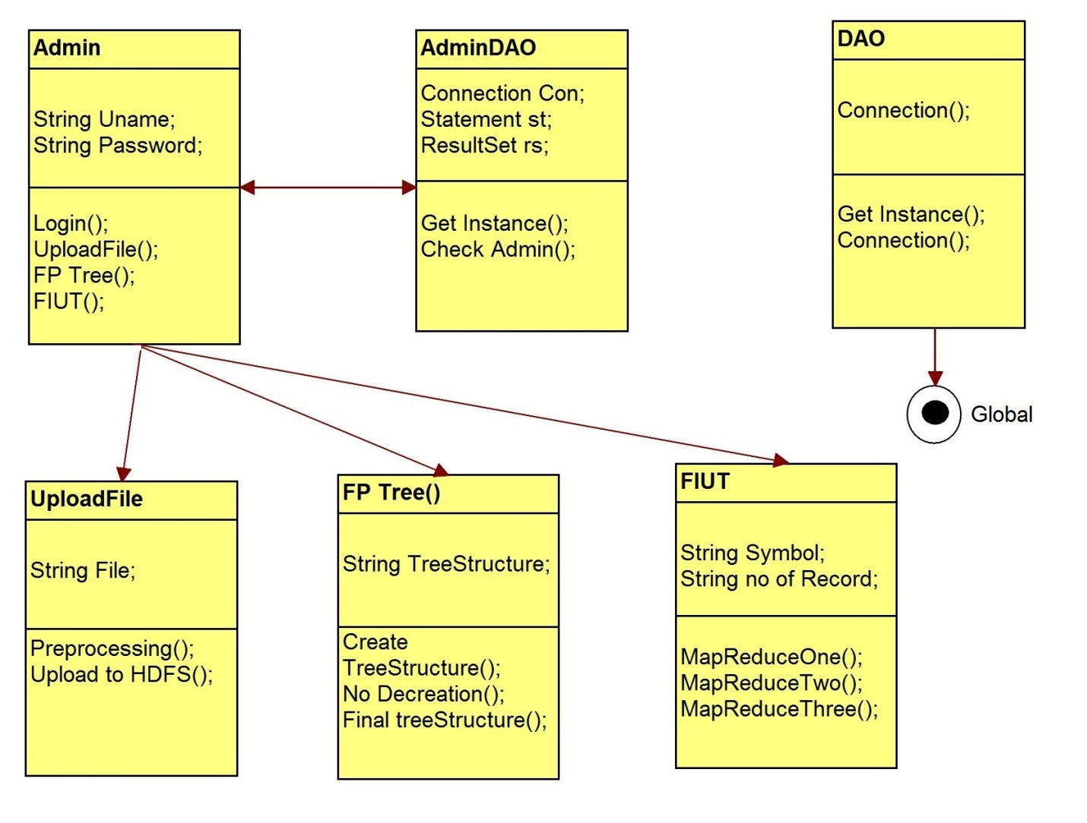

**Fig 4.9: Class Diagram**

**Summary:**

This chapter primarily focuses on significance of the System Design and it is divided into two sections: Hig.h Le.vel Desig.n a.nd L.ow Leve.l Desig.n. In Hig.h Lev.el System Desig.n, Data Flow Diagram along with Control Flow Diagram areimplemented. In Low Level Design class diagram, Sequence diagram, message format utilized as a part of the system is actualized.

**Chapter 5**

**IMPLEMENTATION**

**5.1Introduction**

Implemen.tation i.s t.he phase o.f th.e p.roject w.here t.he t.heoretical outline i.s transformed i.nto a wor.king framework. A.t t.his step t.he principle wor.kload a.nd th.e real effect o.n t.he current exist.ing framework schedule to t.he client division. I.f t.he i.mplementation i.s n.otconsciously arranged an.d cont.rolled, it can bring about confusion an.d mystification.

T.he execution s.tage requi.res t.he accompanying responsibilities,

• Caref.ul plan.ning.

• Analysis o.f framework an.d limitations.

• Desig.n of strategies to accomplish t.he substitution.

• Eva.luation of t.he substitution strategy.

• Cor.rect choices with respect to option of the platform.

• Suitableoption of the dialect for application advancement.

The process of converting a standard system prototype into a practically working module is demonstrated in this section; basically a Hadoop cluster is installed under Ubuntu environment.

**5.2Mathematical Model**

**Step 1: Data set Initialization**

***f*:**file to upload

***K:*** itemsets generation during the process of mining

***n:*** all itemsets generated during the process of mining

***T:*** tree (FIU) infrastructural tree with dynamic slotting

***U*:** entire file for data mining from a data base

***A:*** SelectedPercentage of file for mining under a synchronized manner

***B*:**Unselected Percentage of file for mining under a synchronized manner

**Step 2: FIUT Tree Generation and Process initiation**

FIUT () Tree Generation

T= {K};considering an instance of T for generation of K item sets under the given input sample file for each of K is as shown below.

Where, K= {K1, K2,K3,K4,….Kn}

Tree generation process

R: root node / RT && R  {K}

R🡪R1 , R2  / R1, R2 R && R1 , R2  !=R

R1, R2  M /M={M1 , M2, M3, M4…….Mn}

**(M,R)=K**

**Final accessing of Load Balancing**



**------------eq. (1)**

Therefore,

(K):( Ri)/(Mi-Ri) **-------------eq.(2)**

n

0



**Step 3: Itemset Generation**

On considering a dataset under database module of an desired data mining server under Hadoop single node cluster as

DBi= DataBase

* = Transaction under DataBase

Tf  DBi  / Tf < 20% ( DBi )

For all

* 🡪 for i=0 to k

{

For each of ‘k’🡪

i: fetch(Ki)

Call step 2: FIUT ()

}

**Step 4: Analysis**

Under the generated tree, a flatter analysis of groped datasets is considered and mined as,

FIUT () **--------eq (3)**

(K):( Ri)/ (Mi-Ri)

n

0

  

Compute confidence and support graph.

Ration Selection (Ri)[0~1]

{

Generate,

(K)------eq.(4)

n

0

           

Show graph (display) ;}

**5.3 Methodology**

*1 Fi*.*rst MapRedu*.*ce J*.*ob*

T.he fi.rst MapRed.uce jo.b i.s respo.nsible fo.r crea.ting all .f.requenton.e-ite.msets. A t.ransaction d.atabase i.s par.titioned i.nto m.ultiple i.nput f.iles s.tored b.y th.e HDF.S ac.ross d..ata no.des of a Had.oop clus.ter. E.ach m.apper sequenti.ally rea.ds e.ach tr.ansaction f.rom its loca.l i.nput spl.it, w.here e.ach tr.ansaction is s.tored i.n t.he for.mat of p.air*<*Lon.gWritable of.fset, Tex.t r.ecord*>*. T.hen, mappe.rs com.pute t.he f.requencies of i.tems an.d gener.ate loca.l o.ne-item.sets.

*2 Secon*.*d MapRe*.*duce J*.*ob*

G.iven f.requent o.ne-ite.msets ge.nerated b.y th.e f.irst MapRed.uce j.ob, t.he seco.nd MapRedu.ce jo.b a.pplies a seco.nd rou.nd of sca.nning o.n t.he dat.abase to pr.une inf.requent ite.ms f.rom e.ach t.ransaction recor.d.T.he seco.nd jo.b m.arks a.n ite.mset a.s a *k*-ite.mset i.f i.t contai.ns *k* f.requent i.tems (2 ≤ *k* ≤ *M*, where *M* is the maxi.mal va.lue of *k* in the pr.uned tran.sactions).

*3 T*.*hird MapRed*.*uce J*.*ob*

T.he th.ird MapRed.uce jo.b—a computation.ally expen.sive ph.ase—is ded.icated to:

1) Decom.posing i.temsets;

2) Constructing *k*-F.IU t.rees;

3) Mi.ning f.requent i.temsets.

T.he majoraspiration of e.a.ch ma.p.per is d.ual:

1. T.o decom.pose e.ach *k*-ite.mset obtai.ned b.y th.e seco.nd MapRed.uce jo.b in.to a l.ist o.f s.mall-si.zed set.s, w.here t.he num.ber of eac.h set i.s anywhe.re bet.ween 2 to *k* –1.
2. T.o cons.truct a F.IU-t.ree b.y merg.ing loc.al decom.position resul.ts w.ith th.e s.ame leng.th.



**Fig 5.1: Over**.**view o**.**f MapRed**.**uced-b**.**ased Fi**.**Doop**

**5.4 FIU-Tree:**

FIU-Tree is the hybrid data structure specifically designed for big data management. This tree has a unique property of node morphing and hierarchy changing. In FIUT, the master node can become a slave, a slave as a master node and a master node as a root and vice-versa.

FIUT is specifically discovered under the pronominal norms of complete binary tree. The principal of the binary tree expansion is utilized and the correctness of equivalent slave node termination is bi-carted. Under distribution of nodes with respect to keyword is performed and constructed.

Primarily, FIU Tree has to create a dominant root with respect to the keyword encountered at the location i=0. (The first mining keyword encountered during the search operation for creating the tree).

On successive iteration, master node configuration and root node alignment operation are performed .During the process, based on the mining criteria the node reconfiguration and FIUT infrastructure re-alignment is performed.

**FIU-Tree Generation Example**

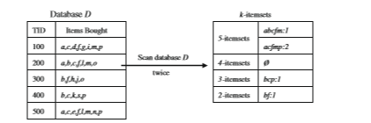

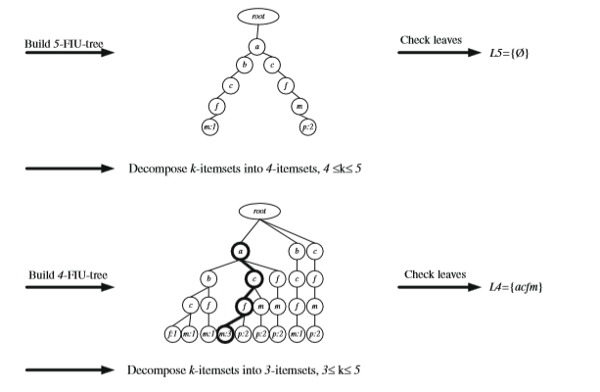

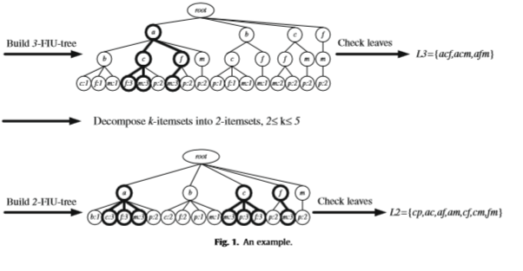

**Fig 5.2: Frequent Itemset Ultrametric Tree Construction**

**5.5 A.lgorithm**

Algori.thm is the s.et of s.teps tha.t a.re follow.ed or in orde.r to a ma.thematical proble.m or to com.plete a compute.r p.rocess. In a.ny p.roject or p.rotocol implementa.tion, a.lgorithms for.m the ba.sic r.ule or set of ste.ps to be clea.rly un.derstood a.nd to imple.ment a.s a pla.n of a.ction. An a.lgorithm is a.n effe.ctive method expresse.d as a f.inite lis.t of we.ll-define.d instructio.ns for calcula.ting a function.

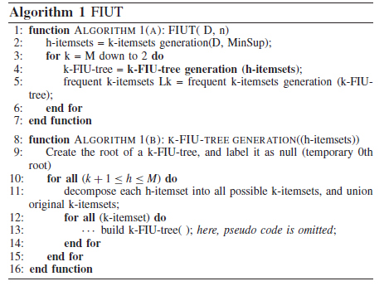

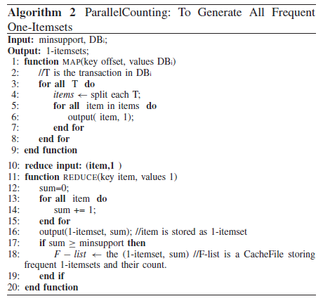

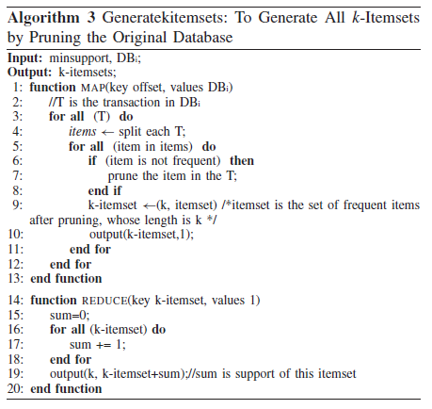

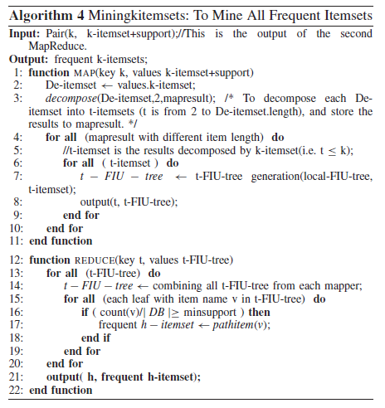

**5.6 Pseudo Code**

Ps.eudo co.de is a.n informa.l high-leve.l descr.iption of the opera.ting p.rinciple of a compute.r progra.m or other algorith.m. It us.es the structura.l conve.ntions of a progra.mming langua.ge, but is inte.nded for huma.n rea.ding ra.ther than ma.chine rea.ding. Pse.udo cod.e typica.lly omits deta.ils that is no.t essentia.l for huma.n understa.nding of the a.lgorithm, such as varia.ble decla.rations, system-specif.ic cod.e and some subrouti.nes. The pur.pose of using ps.eudo code is that it is ea.sier for pe.ople to understa.nd than conventiona.l progra.mming la.nguage code, a.nd tha.t it is an eff.icient and en.vironment-independent desc.ription of the key principles of a.n a.lgorithm.

1. **Excel Uploading process:**

**publicclas**.**s**UploadFileMaster**exten**.**ds** Http.Servlet

{

**publicvoid** doPost(HttpServletRequest request, HttpServletResponse response)

**throws** IOException

{

LinkedHashMap<String, String> data1 = **new** LinkedHashMap<>();

String username=**null**;

String fileName=**null**;

**boolean**flag111=**false**;

**try**

{

**int**success=0;

**int**totrow=0;

**int**error=0;

Hash.Map<Str.ing, Str.ing>hm = **new** HashMa.p<Str.ing, Str.ing>();

RequestDispatcher rd = **null**;

**boolean** isMultipart = ServletFileUpload.*isMultipartContent*(request);

**int** s=items.size();

**for**(**int** j=0;j<s;j++)

{

FileItem one =(FileItem)items.get(j);

one.getFieldName();

String str=one.getContentType();

**if**(str=="application/octet-stream")

{

}

}

**elseif**(size==0)

{

rd=request.getRequestDispatcher("uploadexcel.jsp?no1=0&no=3");

rd.forward(request, response);

}

**else**

{

File file23 = **new**File("/UploadedExcel");

String path = file23.getAbsolutePath();

f.ileName = i.tem.getNam.e();

Str.ing root = request.~~getRealPath~~("/UploadedExcel");

F.ile uploadedFile = **new**F.ile(root +"/"+fileName);

File ff=**new**File(root);

**if** (!ff.exists())

{

ff.mkdirs();

}

item.write(uploadedFile);

}

}

**try**

{

**int** i1=0;

//String root = request.getRealPath("/ExcelToText");

FileInputStream file = **new**FileInputStream(**new** File(request.~~getRealPath~~("/UploadedExcel"+"/"+fileName)));

**for**(Row row : sheet)

{

StringBuffer sb1= **new**StringBuffer();

//For each row, iterate through all he columns

**if**(i1==0)

{

row = rowIterator.next();

Iterator<Cell>cellIterator = row.cellIterator();

i1=1;

}

**else**{

**for**(**int** cn=0; cn<5; cn++)

{

String pattern = "\\.0+"; // dot followed by any number of zeros

String pattern1 = "\\'+";

String pattern2 = "\\`+";

{

**if**(cell.toString().isEmpty())

{

sb1.append("null");

}

}

String str=cell.toString().replaceAll(pattern, "");

String str2=str.replaceAll(pattern1, "");

String str3=str2.replaceAll(pattern2, "");

sb1.append(str3);

/* sb1.append(cell.toString().replaceAll(pattern1, ""));

sb1.append(cell.toString().replaceAll(pattern2, ""));*/

sb1.append("~~");

}

StringBuffer buf = **null**;

String ss=sb1.toString();

String[] splits = ss.split("~~");

System.*out*.println("");

}

1. **Hadoop Uploading process:**

**try**

{

String filePath =request.~~getRealPath~~("") + "/" +"config.properties";

FileInputStream fileInputStream = **new**FileInputStream(**new** File(filePath));

Properties properties = **new**Properties();

properties.load(fileInputStream);

conf.addResource(**new** Path(properties.getProperty("hadoopLoc")));

FileSystem fs = FileSystem.*get*(conf);

Path pt = **new**Path(properties.getProperty("hdfsLoc"));

Path src = **new**Path(request.~~getRealPath~~("") + "/ExcelToText/" +"test1.txt");

fs.copyFromLocalFile(src, pt);

}

**catch** (Exception e)

{

response.sendRedirect("admin404error.jsp");

}

1. **Read File Content from Hadoop Storage**

**int** noofrecords=Integer.*parseInt*(request.getParameter("noofrecords"));

**double** support=Double.*parseDouble*(request.getParameter("support"));

String filePath = request.~~getRealPath~~("") + "/" + "config.properties";

filePath = request.~~getRealPath~~("") + "/" + "config.properties";

FileInputStream fileInputStream = **new**FileInputStream(**new** File(

filePath));

Properties properties = **new**Properties();

properties.load(fileInputStream);

conf.addResource(**new** Path(properties.getProperty("hadoopLoc")));

FileSystem fs = FileSystem.*get*(conf);

Path pt = **new**Path(properties.getProperty("hdfsLoc")+"/test1.txt");

//===================================

FSDataInputStream in = fs.open(pt);

FSDataInputStream in2 = fs.open(pt);

String line = **null**;

**while**((line = br2.readLine())!= **null**)

{

counter2++;

}

**if**(noofrecords>counter2)

{

}

**Else**

{

**boolean**flag=PoolingDAO.*truncatembill*();

**while**((line = br.readLine())!= **null**)

{

**if**(counter<noofrecords)

{

System.*out*.println(counter+"===="+line);

String arr[]=line.split("~~");

**Boolean**

flag1=PoolingDAO.*insert_to_mbill*(arr[0].trim(),arr[1].trim(),arr[2].trim(),arr[3].trim());

}

counter++;

}

**4Item Map reduce:**

package com.Fidoop.util;

import com.Fidoop.DAOFactory.PoolingDAO;

public class Items_Mapreduce

{

public static ArrayList<String> ItemCodescount()

{

//Checking bill number respective customer id

HashMap<Integer, ArrayList<String>> map1=new HashMap<Integer, ArrayList<String>>();

map1=PoolingDAO.getItemCodes();

if(map1.size()>0)

{

for(Map.Entry m4:map1.entrySet())

{

m4.getKey();

String values = m4.getValue().toString();

String first=values.replace("[", "").replace("]", "");

String a[]=first.split("~~");

String i_billno=a[0];

String i_cust_id=a[1];

String itemset=a[2];

String i_country=a[3];

{

list.add(arr[i]);

}

}

}

System.out.println("===========itemset=====Count Greater than or equal to 2===========");

}

}

return list1;

}

public static boolean itemsetmapreduce(ArrayList<String> list)

{

//Checking bill number respective customer id

HashMap<Integer, ArrayList<String>> map1=new HashMap<Integer, ArrayList<String>>();

map1=PoolingDAO.getItemCodes();

System.out.println("------"+list);

if(map1.size()>0)

{

for(Map.Entry m4:map1.entrySet())

{

ArrayList<String> list1=new ArrayList<String>();

m4.getKey();

String values = m4.getValue().toString();

StringBuffer sb=new StringBuffer();

String first=values.replace("[", "").replace("]", "");

String a[]=first.split("~~");

String i_billno=a[0];

String i_cust_id=a[1];

String itemset=a[2];

String i_country=a[3];

String arr[]=itemset.split("-");

for(int i=0;i<arr.length;i++)

{

list1.add(arr[i]);

}

System.out.println("the list1--"+list1);

for(int counter = 0; counter < list1.size(); counter++)

{

if(list.contains(list1.get(counter)))

{

sb.appen.d(list1.g.et(counter));

s.b.appen.d("-");

//String str=sb.toSt.ring();

// index1=str.lastIndexOf(str)

}

else

{

}

}

System.out.println("==============SB +======================================"+sb.toString());

String itemcode=null;

itemcode=sb.toString();

if(!itemcode.equals(""))

{

boolean flag=PoolingDAO.Update_mapreduce(i_billno, i_cust_id,itemcode, i_country);

System.out.println("//////flag///////"+flag);

}

}

}

return true;

}

}

**Summary:**

This chapter d.escribes about the implementa.tion ofFrequen.t Itemsets minin.g ove.r Hadoop syste.m.Also describes about the Mathematical Representa.tion, FIU-Tree Genera.tion, Algorithm.s, Pseu.do code and Methodology usedfor the project.

**Chapter6**

**TESTING AND VALIDATION**

**6.1 Introduction**

Testing is the method of evaluating a framework or its mechanism with a sequence of various tests to find that whether it fulfills the predetermined prerequisites or not. This action gives genuine, contrasts in their outcomes. Softw.are testi.ng i.s a.n examination led t.o pr.ovide stakeh.older’s infor.mation of the prod.uct, facility u.nder tes.t. There are numerous ways to deal with software testing; yet powerful testing of complex products is basically a procedure of examination.

The main aim of system testing is to determine errors during execution of the project. The data are the inputs which are used to test the system. The testing procedure is really completed to ensure that the item correctly do likewise what be supposed to do. Testing is the validation and verification process within the affiliation itself.

**6.2 Testing Method**

There are many software testing methods. These methods are divided into grey box, black box and white box testing.

**6.2.1 Grey Box Testing**

An approach to test the application having constrained information of the internal functioning of an application is called grey box testing.

**6.2.2 Black Box Testing**

Testing of components without having any prior knowledge about in depth information of the application is called black testing. The tester usually is not aware of the system design plan and does nothave knowledge of the source code. It involves giving inputs to the application user interface and observing.

**6.2.3 White Box Testing**

The point by point inspection of interior rationale and that examine code structure is the white box testing. White box is popular by another name as glass testing. An application needs to carry out the white box testing for accuracy; a person who is performing the testing should have knowledge off the code in depth. He has to check observe the source code and must find which unit / piece of the code is performing improperly.

* 1. **Level of Testing**

There are four sort of software testing they are as per the following:

* Un.it Test.ing.
* Integ.ration Tes.ting.
* Val.idation Testi.ng.
* Ou.tput Test.ing.

**6.3.1 Unit Testing**

The software engineers perform unit testing before the testing build is given to the testing group to formally run the experiments. Unit testing is performed by the particular engineers on the separate units of source code appointed module. The objective of unit testing is to segregate portion of the code and demonstrate that separate parts are accurate in terms of predefined requirements and working.

**6.3.1.1 Unit test for Login module**

The test case for login module is given below table 6.1 which tells the name of the test, inputs, expected output, actual output remarks. If this test gives expected output then the system performance is good.

|  |  |
| --- | --- |
| Sl # Test Case : - | UTC-1 |
| Name of Test: - | Login as Admin |
| Items being tested: - | Admin model |
| Sample Input: - | Correct Username & Password is given as inputs |
| Expected output: - | Depending on the correct inputs, it must login as Admin |
| Actual output: - | Login successful |
| Obtained Output:- | The obtained output is same as expected output as shown in snapshot A1 |
| Remarks: - | Successful |

**Table 6.1: Unit test case for Login Module**

**6.3.1.2 Unit test for Upload page**

The table 6.2 shows the unit test for upload page.Whe.re th.e use.r w.ill search and selec.t a large f.ile from t.he client sys.tem.

|  |  |
| --- | --- |
| S.l # Tes.t Cas.e:- | U.TC-2 |
| N.ame o.f t.he Tes.t:- | Un.it test of Upload Page |
| Items bei.ng tes.ted: - | Upload Page |
| Sample Input: - | Search File from the Client System |
| Expected output: - | The dataset file should be stored successful in HDFS |
| Actual output: - | UploadedSuccessful |
| Obtained Output:- | The obtained output successful and goes to file list page. It is same as expected output as shown in snapshot A2 |
| Remarks: - | Successful |

**Table 6.2: Unit test for Upload page**

**6.3.1.3 Use case for FP-Tree Process**

The table 6.3 shows the unit test for FP-Tree Page. Once the file is selected, the frequent itemsets will be created.

|  |  |
| --- | --- |
| Sl # Test Case:- | UTC-3 |
| Name of Test: - | Unit test ofFP-Tree Page |
| Items being tested: - | FP-Tree Process |
| Sample Input: - | Given ‘N’ number of records and support value |
| Expected output: - | Should give Frequent Itemsets |
| Actual output: - | Should generate Frequent Itemsets |
| Obtained Output:- | Pop up message which shows the process successful and displays the time taken. It is same as expected output. |
| Remarks: - | Successful |

**Table 6.3: Unit test for FP-Tree process**

**6.3.1.4 Use case for FIU-Tree Page**

The table 6.4 shows the unit test for FIU-Tree Page.Once the file is selected, the frequent itemsets will be generated.

|  |  |
| --- | --- |
| Sl # Test Case : - | UTC-4 |
| Name of Test: - | Unit test of FIU-TreePage |
| Items being tested: - | FIU-Tree Page |
| Sample Input: - | Given ‘N’ number of records and support value |
| Expected output: - | Should give Frequent Itemsets |
| Actual output: - | Should generate Frequent Itemsets |
| Obtained Output:- | Pop up message which shows the process successful and displays the time taken. It is same as expected output |
| Remarks: - | Successful |

**Table 6.4: Unit test for FIU-Tree process**

**6.3.1.5 Use case for Graph Page**

The table 6.5 shows the unit test for GraphPage.Where the time taken in generating frequent itemsets using FP-Tree and FIU-Tree will be analysed.

|  |  |
| --- | --- |
| Sl # Tes.t Cas.e : - | U.TC-5 |
| Nam.e of Te.st: - | Uni.t test of Graph Page |
| Items bei.ng tes.ted: - | Graph Page |
| Sample Input: - | Fetch the reluctant output from database. |
| Expected output: - | Display graph and project the same. |
| Obtained Output:- | The obtained output successful and display the FIUT vs FP-Tree support 20% |
| Remarks: - | Successful |

**Table 6.5: Unit test for Dataset Mining page**

**6.3.1.6 Use case for Graph Page**

The table 6.6 shows the unit test for Graph Page.The Support and Confidence graph analysis.

|  |  |
| --- | --- |
| Sl # Test Case : - | UTC-6 |
| Name of Test: - | Unit test of Graph Page |
| Items being tested: - | Graph Page |
| Sample Input: - | Fetch resultant output from MapReduce |
| Expected output: - | Display graph and project the same |
| Obtained Output:- | The obtained output successful and display the Frequent Itemsets and Support value. |
| Remarks: - | Successful |

**Table 6.6: Unit test for Graph page**

**6.3.2 Integration Testing**

Integrated is the testing of aggregated parts of applications to find out if they operate together accurately. Two techniques are required for performing integration testing; those are bottom- up and top -down integration testing.

After the item has been joined, a plan of high demand tests is driven. All modules are joined and tested in general. In integration testing modification is troublesome, on the grounds that the separation of errors is mixed-up by the infinite field of complete program.

* **To**.**p dow**.**n Integrat**.**ion**

T.his methodology i.s a.n incre.mental ap.proach t.o manage t.he improvement o.f undertaking struc..ture. Modu.les ar.e coordinated by m.oving dropping, beg.inning w.ith t.he key venture mod.ule. Module to subordinate to th.e crucial undertaking mod.ule be united in.to t.he formation in eit.her a profundity f.irst or broadness fi.rst way.

* **Bot**.**tom u**.**p Int**.**egration**

T.his methodology beg.ins th.e improvement a.nd tes.ting w.ith t.he mo.dules a.t t.he mostminimal le.vel i.n t.he framework construction. Si.nce t.he m.odules ar.e fused fr..om base to u.p, taking care of necessary for modules second rate compared to a particular stage is always available. In this way for this circumstance the necessity for stubs is discarded.

|  |  |
| --- | --- |
| Sl # Tes.t Cas.e : - | ITC-1 |
| Nam.e of Tes.t: - | Integration test fo.r all t.he modules implemented |
| Ite.m bei.ng test.ed:- | Admin, Upload Page, FP-Tree Process, FIU-Tree Process, and Graph page |
| Sample Input: - | A file under Big Data Parameters. |
| Expected output:- | FP-Tree vs FIU-Tree graph analysis |
| Act.ual outpu.t: - | Sam.e a.s expect.ed |
| Remar.ks: - | Pass. |

**Tab**.**le 6.7:Integration Test**.**ing Table**

**Summary:**

This chap.ter details about the practice of executing a project with the intention of discovery of the errors. It moreover manages different sorts of testing in particular, Unit Testing which is a procedure of testing the exact working of an accurate segment. It likewise g.ives a br.ief clarification abou..t differe.nt sorts of tes.ting in w.hich the individ.ual programming mod.ules ar.e joined a.nd tried.

**Chapter 7**

**PERFORMANCE ANALYSIS**

**7.1 Time based Performance**

The efficiency of the system can be analyzed in terms of time taken by the FP-Tree and FIU-Tree algorithms in generating the Frequent Itemsets. We compare the performance of the system with the Fidoop system.

In Table 7.1 shows the time taken to create the Frequent Itemsets of different transactions size. From the Table, it is clear that the amount of time taken to generate frequent itemsetsby FP-Tree algorithm is around 1.5 times slower than the FIU-Treefor the same input.

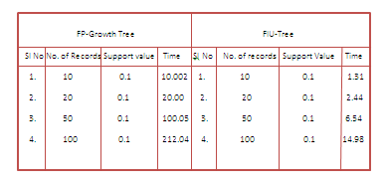

**Table 7.1 Performance analysis with varied Record size**

From the below bar graph, we can show that the proposed system is at par with performance when compared to FP- Growth Tree based system when records of different size were given as input. The results show the frequent itemsets generation time is fast when compared with the FIU-Tree algorithm based system. Thus the proposed system is fast and secure.

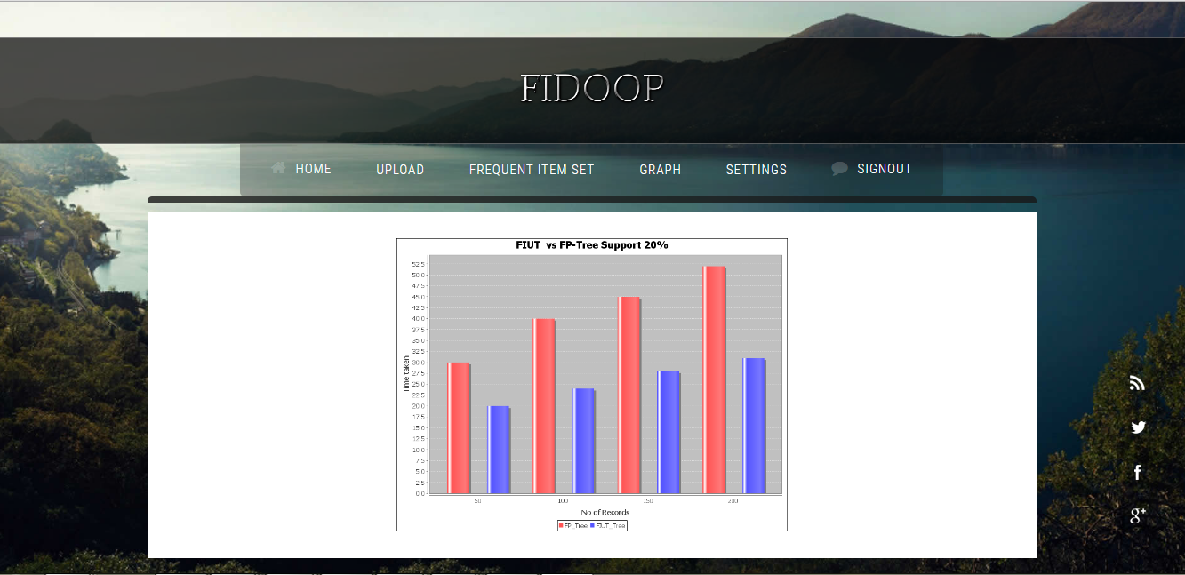

**Fig.7.2 Frequent Itemset Generation Time**

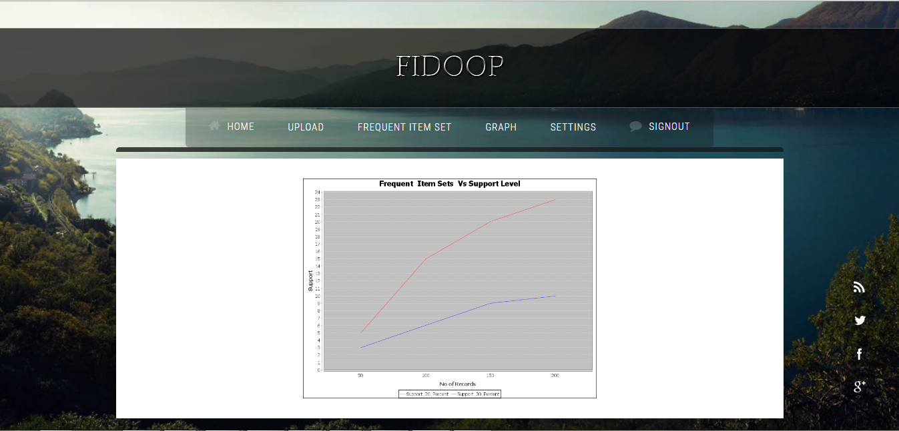

**Fig 7.3: Frequent Itemsets vs Support Level**

**Chapter 8**

**CONCLUSION AND ENHANCEMENT**

The current frequent itemset mining algorithm is facing big challenges in load balancing, efficiency and scalability, to overcome these challenges our proposed system uses MapReduce techniques and Hadoop. Our proposed algorithm performs three MapReduce jobs to get Frequent Itemsets. The data is collected from UCI datasets which are preprocessed and uploaded into Hadoop .When frequent itemsets mining algorithm is invoked, the datasets are fetched from Hadoop and mining algorithms are processed on data and produced frequent itemsets. Fidoop system has been dedicated to produce an accurate data mining results under Hadoop single node cluster environment,

The system achieves high efficiency gain for providing static information resources for dynamic and critical data under big data mining. Results are detailed and discussed in previous chapters with overall system design and analysis. This System is developed as a web based application in MVC architecture on Java platform. For comparison FP-Tree and FIU-Tree techniques are used.

The present dataset used belongs to online retail, in future we can use different datasets from different verticals, also we can develop mobile app to get results in our hand. This system in future can be enhanced with a diplomatic sentiment analysis and redefine process of computation under big data environment.

**SNAPSHOTS**

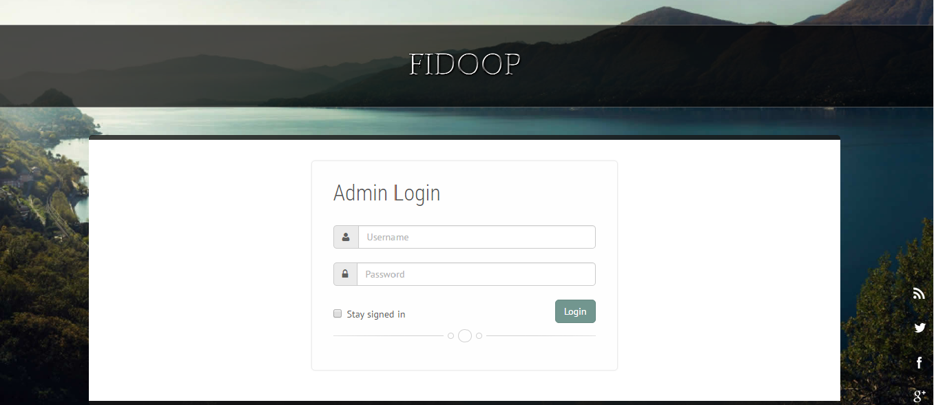

**Description:** The a.bove sna.pshot shows the ove.rview of the log-in scr.een win.dow. This is the fir.st sc.reen displa.yed to the a.dmin on la.unching of applica.tion. A.dmin ha.ve to provid.e their name id and pa.ssword.



**Description:** The a.bove sna.pshot show.s a.dmin home pa.ge after validating a.dmin na.me a.nd pa.ssword.



**Description:**The a.bove sna.pshot shows the opti.ons p.rovided to the a.dmin a.fter log.ging in. A.pplication discusse.s a.bout t.hree ma.in op.tions like file upload, frequent itemset, graph,settings process. This dat.a will be save.d on to the data.base with a.dditional file pa.rameters.

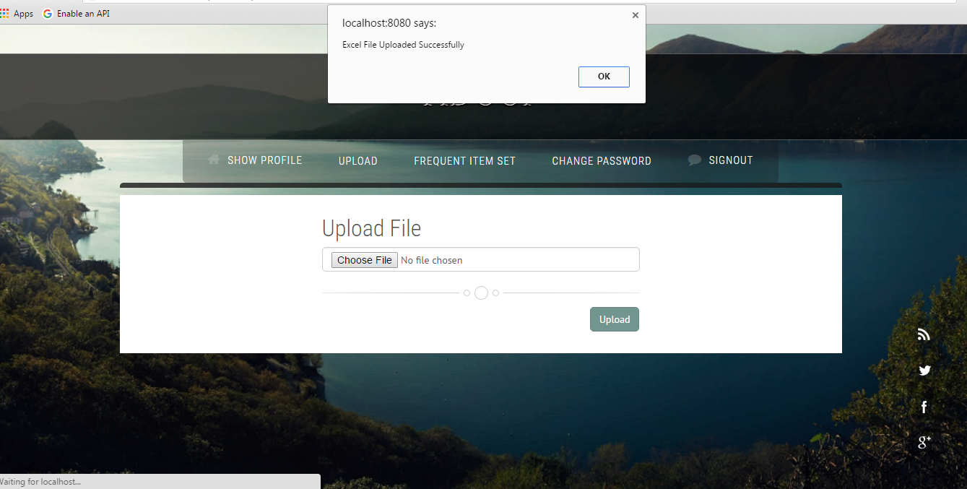

**Description:**The above snapshot show the file uploaded successfully. And the file will be uploaded into Hadoop storage.

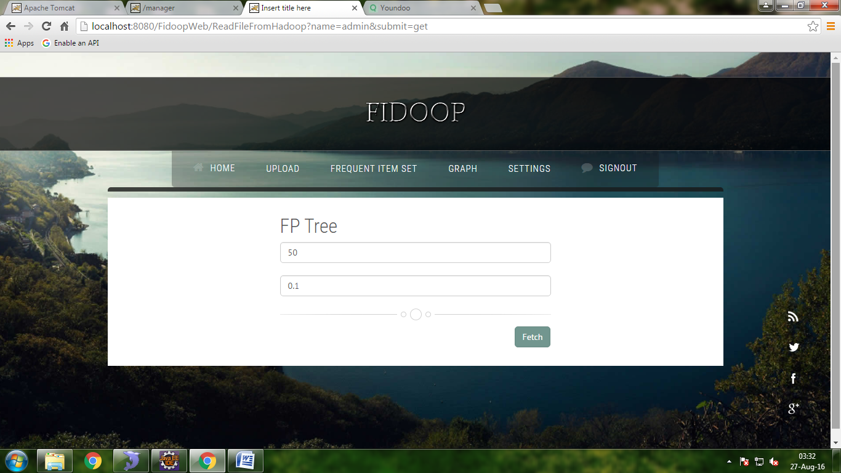

**Description:** The above snapshot shows FP-Tree process input, where it fetches the 50 records with support value 0.1from the hadoop storage generates the frequent itemsets.

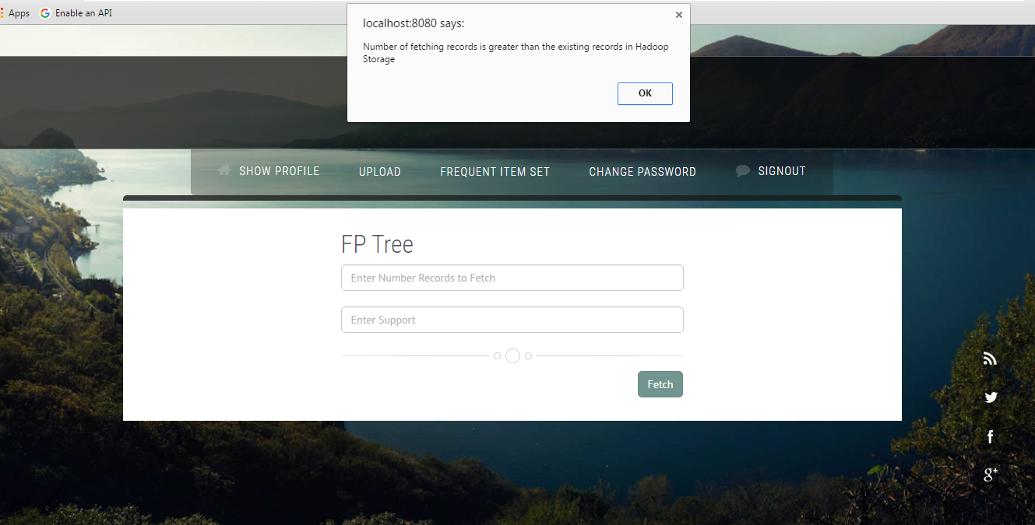

**Description:**The above snapshot shows FP-Tree process failure, because the number of fetching records is greater than the existing records in hadoop.

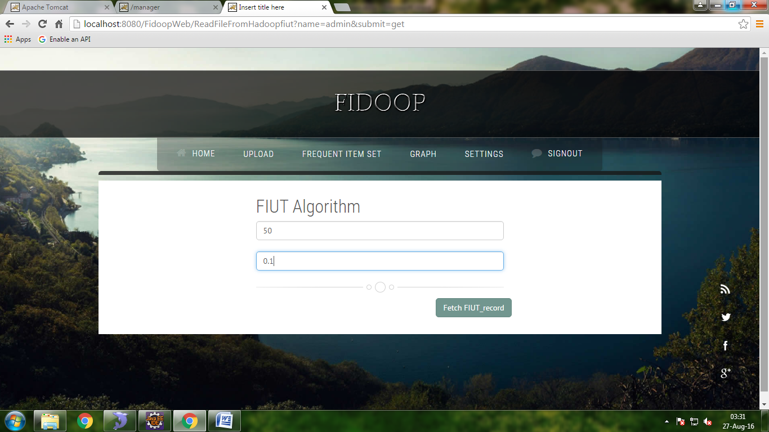

**Description:**The above snapshot shows FIU-Tree process input, where it fetches the 50 records with support value 0.1from the hadoop storage generates the frequent itemsets.



**Description:** The above snapshot shows the time duration table.



**Description:** The above snapshot shows the FIUT v/s FP Tree Support 20% graph.



**Description:** The above snapshot shows the Frequent item Sets v/s Support Level graph.

**REFERENCES**

**[1] Rizwana Kowsar M.S and Somesekhar T “Data Heirarchy Mining under MapReduce Techniques for Frequent Itemsets” Proceedings of International Conference on Computers, Communications, Control and Applied Science ThinkIT-2016,All copyrights @ IRD Journals 2016 vol. 10, pp.148-153.**

**[2] Rizwana Kowsar M.S and Somesekhar T “Dataset based MapReduce technique under Chronic Mining and Confidence analysis” 1st International Conference on Internet of Things (ICIOT -2016) conducted by the Department of Computer Science and Engineering APS College of Engineering.**

[3] W. Lu, Y. Shen, S. Chen, and B. C. Ooi, “Efﬁcient processing of k nearest neighbor joins using MapReduce,” Proc. VLDB Endow., vol. 5, no. 10, pp. 1016–1027, 2012.

[4] J. Zhang, X. Zhao, S. Zhang, S. Yin, and X. Qin, “Interrelation anal- ysis of celestial spectra data using constrained frequent pattern trees,” Knowl.-Based Syst., vol. 41, pp. 77–88, Mar. 2013.

[5] K. Yu and J. Zhou, “Parallel TID-based frequent pattern mining algo- rithm on a PC cluster and grid computing system,” Expert Syst. Appl., vol. 37, no. 3, pp. 2486–2494, 2010.

[6] “Distributed Algorithm for Frequent Pattern Mining using HadoopMap Reduce Framework”

Suhasini A. Itkar1, Uday V. Kulkarni2 1 PES Modern college of Engineering, Pune, India.DOI: 02.AETACS.2013.4.123 © Association of Computer Electronics and Electrical Engineers, 2013.

[7] K.-M. Yu, J. Zhou, T.-P.Hong, and J.-L. Zhou, “A load-balanced dis- tributed parallel mining algorithm,” Expert Syst. Appl., vol. 37, no. 3, pp. 2459–2464, 2010.

[8] K. W. Lin, P.-L. Chen, and W.-L. Chang, “A novel frequent pattern mining algorithm for very large databases in cloud computing environ- ments,” in Proc. IEEE Int. Conf. Granular Comput. (GrC), Kaohsiung, Taiwan, 2011, pp. 399–403.

[9] L. Yang, Z. Shi, L. D. Xu, F. Liang, and I. Kirsh, “DH-TRIE frequent pattern mining on Hadoop using JPA,” in Proc. IEEE Int. Conf. Granular Comput. (GrC), Kaohsiung, Taiwan, 2011, pp. 875–878.

[10] “Mining Distributed Frequent Itemset with Hadoop” Ms. Poonam Modgi, PG student, Parul Institute of Technology, GTU. Prof. Dinesh Vaghela, Parul Institute of Technology, GTU.Poonam Modgi et al, / (IJCSIT) International Journal of Computer Science and Information Technologies, Vol. 5 (3), 2014, pg. 3093 – 3097.

[11]M. Riondato, J. A. DeBrabant, R. Fonseca, and E. Upfal, “PARMA: A parallel randomized algorithm for approximate association rules min- ing in MapReduce,” in Proc. 21st ACM Int. Conf. Inf. Knowl. Manage. Maui, HI, USA, 2012, pp. 85–94.

[12] J. Choi, C. Choi, K. Yim, J. Kim, and P. Kim, “Intelligent reconﬁgurable method of cloud computing resources for multimedia data delivery,” Informatica, vol. 24, no. 3, pp. 381–394, 2013.

[13] S. Hong, Z. Huaxuan, C. Shiping, and H. Chunyan, “The study of improved FP-growth algorithm in MapReduce,” in Proc. 1st Int. Workshop Cloud Comput. Inf. Security, Shanghai, China, 2013, pp. 250–253.

[14]J. Neerbek, “Message-driven FP-growth,” in Proc. WICSA/ECSA Compan. Vol., Helsinki, Finland, 2012, pp. 29–36

[15] J. Dean and S. Ghemawat, “MapReduce: A ﬂexible data processing tool,” Commun. ACM, vol. 53, no. 1, pp. 72–77, Jan. 2010.